Crosby House Bank

Contents

Analysis 4

Description 4

Stakeholders 5

Why my project is amenable by a computational Approach. 6

Project Research 7

Interview with Primary Stakeholder: Mr Arnold 7

Interview with Secondary Stakeholder: Nick Cheepchiewcharnchai 8

Similar Solution 1: Barclays Online Banking 9

Similar Solution 2: HSBC Online Banking 17

Similar Solution 3: PayPal.com 25

Similar Solution 4: Local ATM 30

Hardware and Software Requirements 35

Hardware Requirements: 35

Software Requirements: 35

Essential Features 36

Limitations 37

Success Criteria 38

Design 40

Entity Relationship Diagram 40

Justification of Entity Relationship Diagram 40

Tables 41

TblUsers 41

TblTransactions 42

TblBalanceTrack 44

Top Down Design 45

Justification for Top down design 46

Draft Page Design 47

Test Data 49

Users 49

Transactions 51

Balance Track 53

Detailed Page Design 55

Login Page 55

Student Home Page 57

Student Withdraw Page 59

Student Deposit Page 62

Admin Home Page 65

Admin add students page 67

Admin Remove Students Page 69

Admin View Students Page 71

Admin Student Spending Page 73

Admin Confirm Transactions Page 76

Admin Balance Update Page 78

Development 80

Creating Database and Tables 80

Creating TblUsers 80

# Analysis

## Description

My project Idea is to create a database for my boarding house that eases the management of the house bank. The Crosby House Bank allows pupils to deposit cash for safe keeping in the house safe and then withdraw the cash in large sums or small amounts . Currently this process is almost completely physical with pupils asking the Housemaster or Deputy Housemaster to withdraw money from the safe. Therefore the aim of my project is to make a web based database that allows pupils to ask for money digitally as well as allowing pupils to check how much money they have in house bank. It will also allow the house master and deputy house master to easily track who has asked to withdraw money and who has deposited money.

## Stakeholders

For my project I intend to have two levels of stake holders:

* **Primary Stake Holder**: Mr Arnold(Deputy Housemaster of Crosby Houser) :
  + Mr Arnold is currently the person in charge of managing the house bank. This means he receives cash from the student and deposits it in house bank as well as giving students money out of house bank when they request cash. This also means he is in charge of tracking how much money each student has in house bank and whether a student has drawn out too much money to the point where they are in debt. The project will allow Mr Arnold to view student balances because this will make it easier for him to view which students are currently in debt and by how much they are in debt. Furthermore, the project will allow him to manage student balances completely electronically by inputting the amount a student has deposited or withdrawn which will make it much easier to control student balances. In addition to this Mr Arnold currently has to tell students in person when they are in debt to house bank and how much money they owe, in person. Therefore this project will allow him to notify students remotely making the process much quicker.
* **Secondary Stakeholder:** Students of Crosby House.
  + The students of Crosby house currently make use of the house bank as it allows them to store cash in safe so that it is secure and then withdraw amounts at a later date. Students also use house bank for convenience. For example, when people come around house collecting money for charity or staff gifts, students can choose to use money from house bank to cover the costs of their donation instead of using Cash. However when students want to take money out of house bank they have to knock on Mr Arnold’s door and ask to take money out of house bank. Therefore my project will allow the students to request money out of house bank remotely via the house bank website. In addition to this students currently do not have any way of checking how much money they have in their house bank. Therefore students will be able to use the house bank website to check their balances in house bank.

## Why my project is amenable by a computational Approach.

* One of the features of my project is that I want to allow individual students to view the amount of money they currently have in house bank without being able to view other people’s accounts. This is amenable by a computational approach as I will need a login system online so that the students can view their own house bank balance and not another students. Furthermore, I will need an admin login so that only Mr Arnold can manage the house bank database and no other person that is not an admin.
* Another feature that my project will have is remote access to their house bank balances. This will be done via a website that Crosby students will be able to acess via their web browser. This is therefore can only be done via a computational approach as a physical approach does not allow students to acess their balances from anywhere they want whereas a computational approach will allow students to access the database online.
* Furthermore another feature that makes my project amenable by a computational approach would be that account balances are automatically updated when a person takes money out of house bank. For example, when a person takes cash out of house bank the amount of money in the safe will also get updated as well as the students account balance. Therefore this can only be done out of a computer as a physical version of this system would require both accounts to be updated individually
* Another feature would be the ability to view multiple account balances at once. For example, if the administrator wanted to view the house bank account they would have to log onto a online banking service but in order to view the cash available in the house safe the admin would have to check a sheet of paper or even count the cash in the safe if the amount is not regularly updated.

## Project Research

#### Interview with Primary Stakeholder: Mr Arnold

In my interview with Mr Arnold he showed me the current system that was in place which was a very simple database that showed student balances. He then described to me what both the student and administrator needs to be able to do as well as a general explanation of how he wants the system to work. Below is the notes I took while talking about the house bank database.

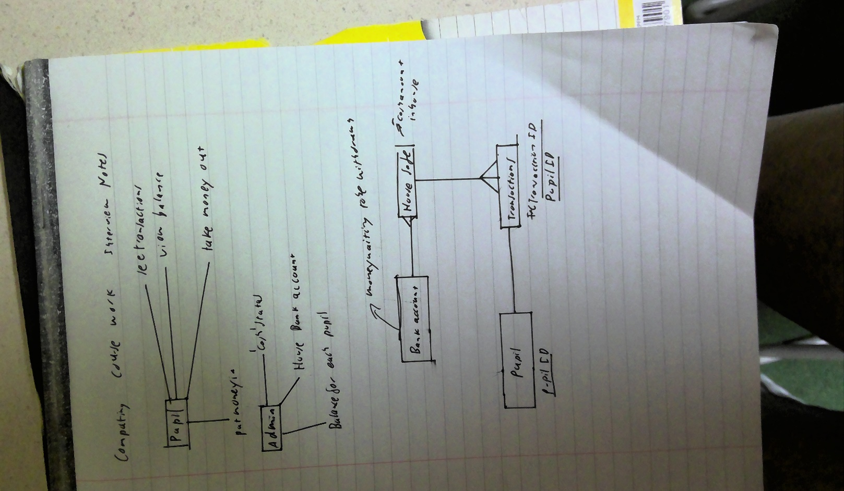

#### Interview with Secondary Stakeholder: Nick Cheepchiewcharnchai

* **How do you currently feel about Crosby house bank**
* House bank is useful to keep large sums of money as it prevents you from losing it. It is good because your parents can transfer in money which you can take out as cash
* **What do you currently use house bank for?**
* I use house bank mainly to take out large sums of money when I run out of cash for taxis. It is also very useful when I want to donate money to charity. For example, with Wyatt carnations I used house bank to cover the 1 pound cost.
* **What are your current problems with house bank?**
* There is no problem when I have to donate money but when I have to take money out myself I have problems because sometimes when I need to get money Mr Arnold is not available for me to get money from him and by the time he is available I forget about needing to take money. I also often forget much money I specifically have in house bank
* **How would you improve Crosby house bank?**
* It would be easier if there was a sheet of paper that Mr Arnold can leave out so that we can request money without disturbing him so that he can see the request and give it to us at dinner. It would also be helpful if there was a place in Crosby where we could see how much money we had in house bank but there would be an issue with privacy of people account balances

### Similar Solution 1: Barclays Online Banking

For this I will be analysing the Barclays banking mobile application. This will allow me to look at how some banking apps are laid out on a mobile phone. All screenshots have been taken from a Barclays Banking video so there is no sensitive information.

**Main Page for Barclays Banking**

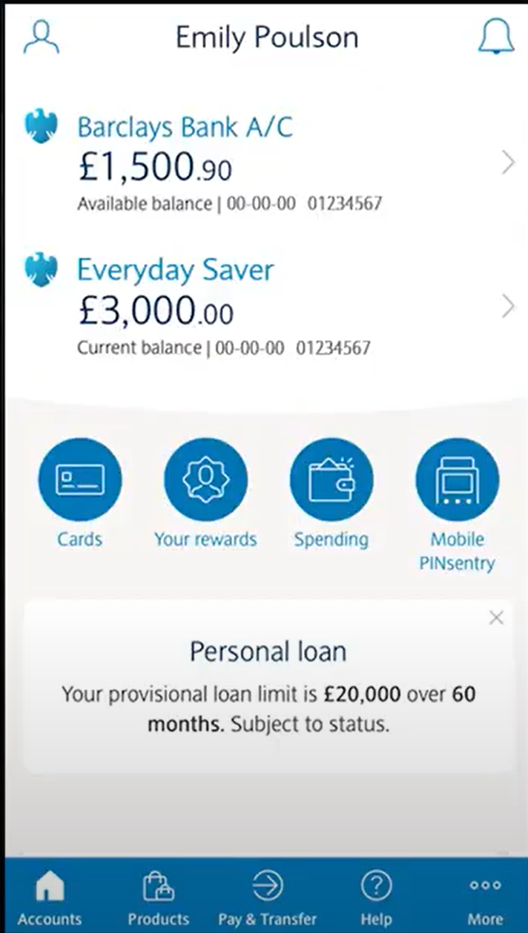

This is a good example of a home page. I like how it displays the balance on the account on the main page. I also like the bar a the bottom allowing to go to different parts of the interface. However I dislike the amount of different features there are on the main page. For my project the website will not offer as many features. For example rewards and products are completely unnecessary features that my project will not offer. In addition I like how there is a help button to explain how to use the website.

**Page Displaying Balance and Transactions.**

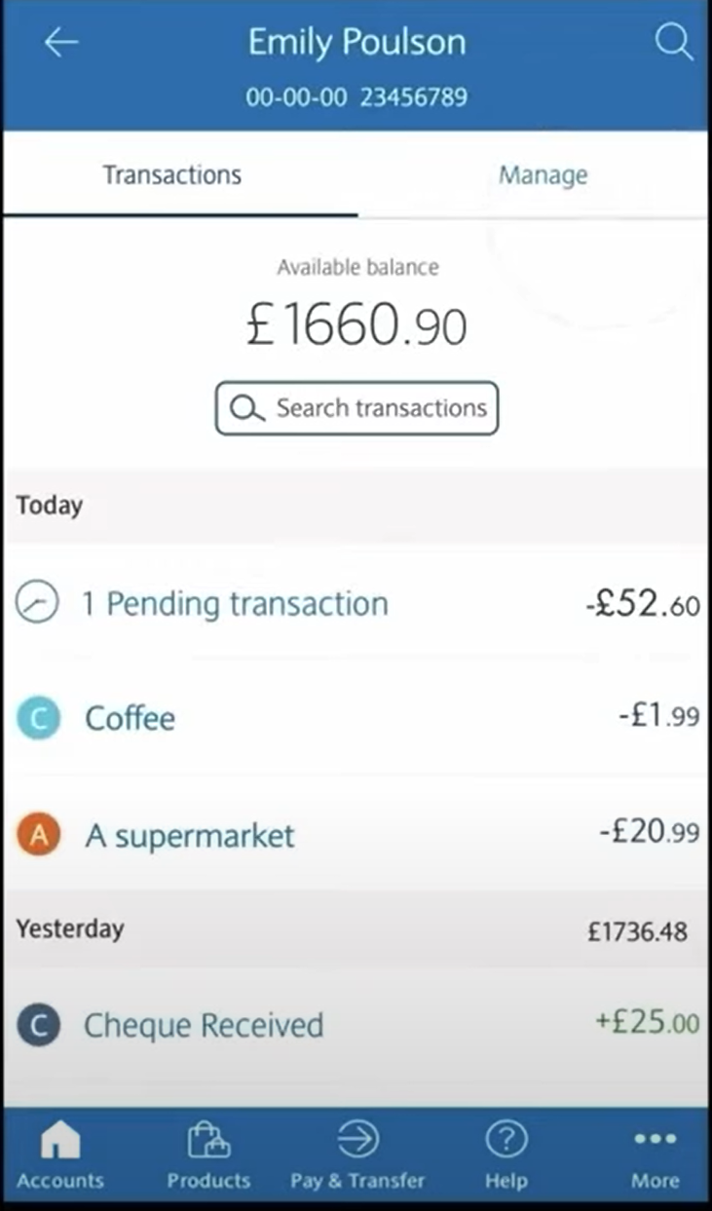

This page displays the account balance. I like the layout of the interface with account balance at the top of the page. I also like how it displays the transaction history of the account with amounts next to the transaction. I also like how it shows what each transaction was for example super market. I think I will use this feature so that the students can keep track of what they used their house bank money for. I do not intend to use a search transactions as it will be to complicated to implement. I also do not intend to allow students to manage their own accounts however the manage an transaction bar will be useful for the administrator to have when viewing student accounts.

**Credit Card Page.**

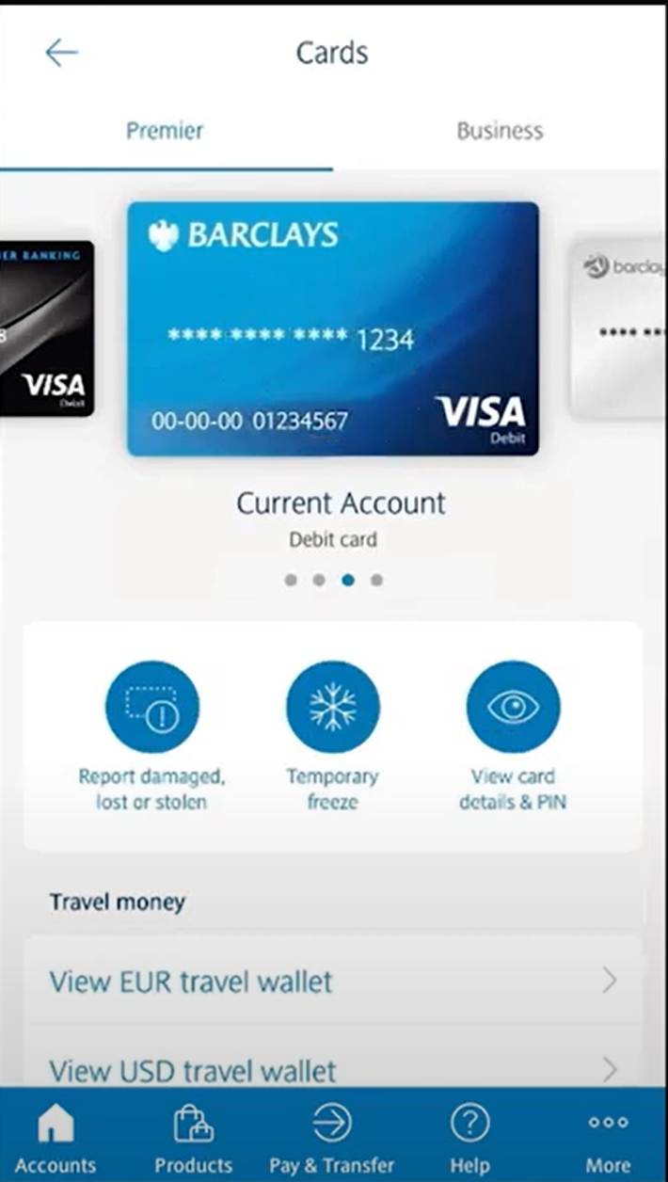

This is a completely unnecessary feature as my project will not use credit or debit cards.

**Login Page for Barclays account**

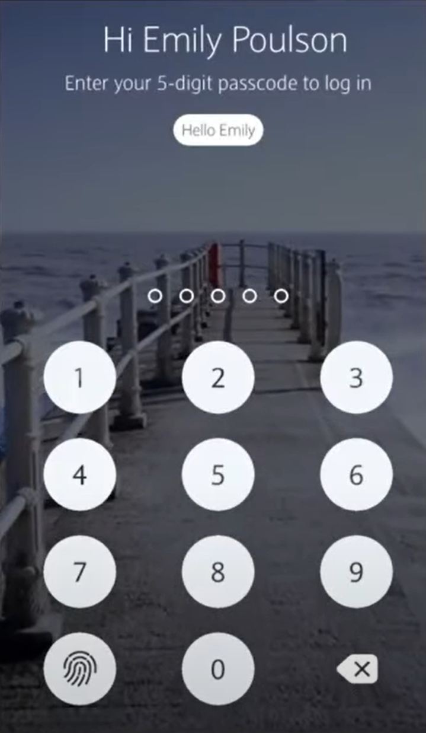

This website uses a 5 digit passcode to login to the online banking system. I do not think I will implement this into my project as this banking system remembers the user so all it needs to do is get confirmation that it is the user logging into the account. However for my project the website will not be able to identify that it is the same user logging on therefore it will need a username and password to login.

**Payment System for Barclays Online Banking**

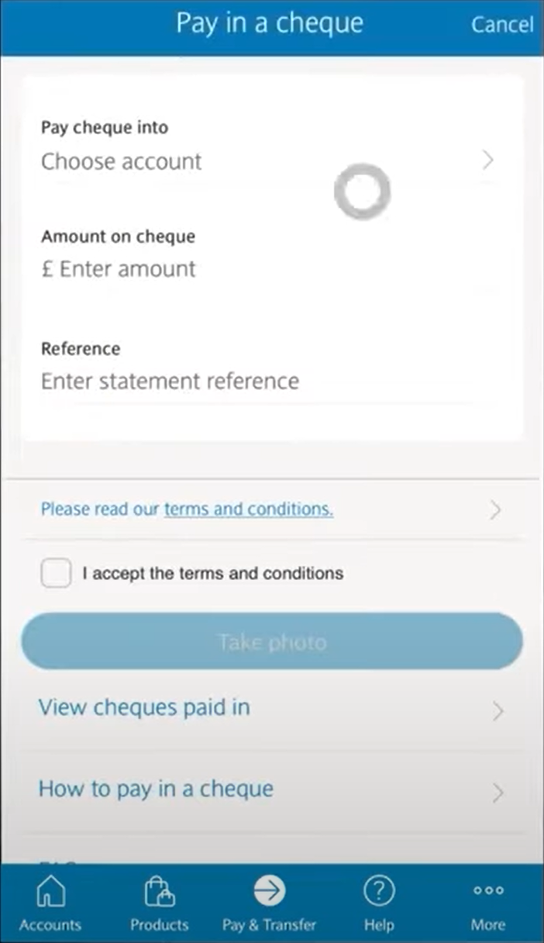

My system will not be using cheques so this is an unnecessary feature.

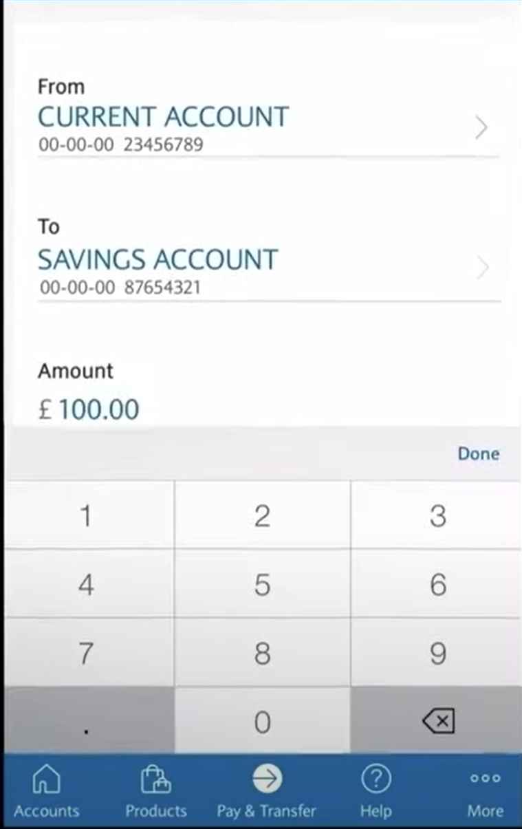

This payment process is much more complicated than the payment process that the house bank will have. This is because for this payment you have to select the account that you want to send from and the account you want to send to. However with my project you will only be dealing with one accounts as you will either be depositing money into house bank or withdrawing money from house bank.

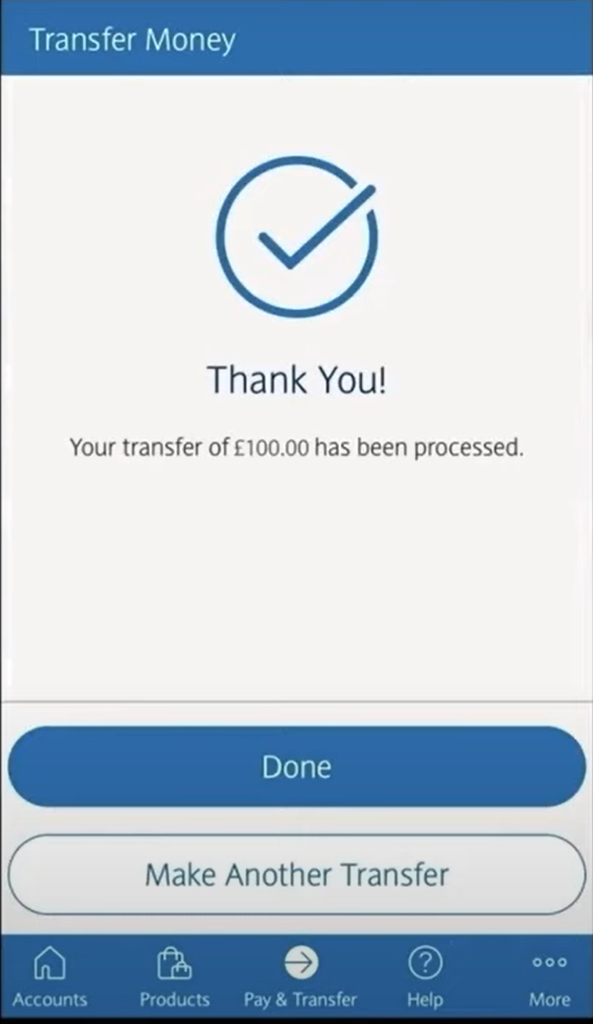

I like this confirmation page as it allows you to make another transfer. Furthermore I like the big tick in the middle of the page and will be implementing this into my project. I will probably use this page as a guide for the completion of payment page.

**Summary of key features Identified:**

* The nav bar at the bottom of the page is a suitable approach to how I would like my website to be displayed on a mobile device as it is simple and only shows the key features.
* The confirmation page is good as it allows the user to make another transfer directly from the page instead of having to repeat the whole process again.
* Additionally, the payment system is very good as you easily choose an account to transfer to and select an amount. This would be very good for transferring money from house bank account to house safe as the date is not required as a detail.

### Similar Solution 2: HSBC Online Banking

HSBC also has an online banking app and website. This provides me a good example of how I might layout my website on a desktop format. It will also provide insight into the functionality of an online banking site.

**Main Banking Page**

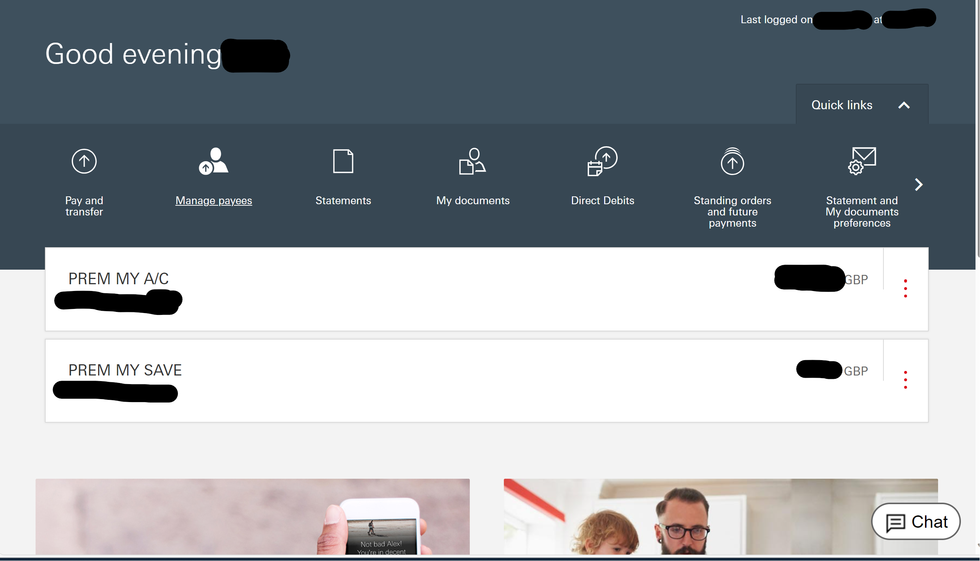

In this image I really like the layout of the menu bar at the top of the screen. Similar to Barclays banking my website will not have as many features so there will not be as many things in the nav bar. I prefer this layout of the navbar at the top of the screen much better than the navbar at the bottom of the screen. However I do not like the collapsable menus as the can cause the website to get quite messy and the colour scheme is very bland. Furthermore I do not like how the menu bar is stays in the upper middle part of the screen instead of the top

**Individual Accounts**

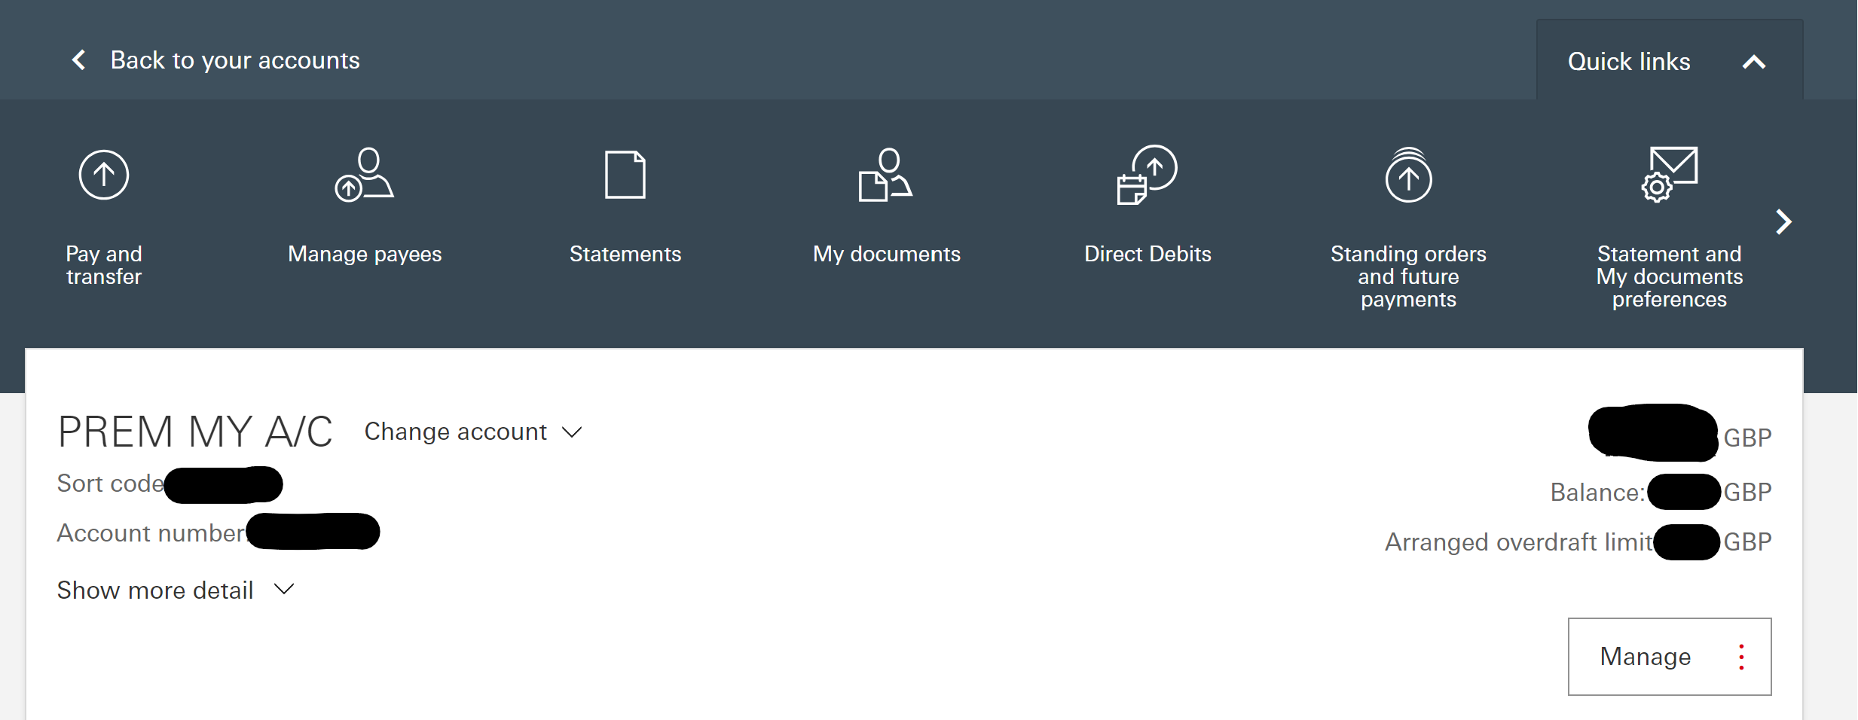

I like the simplicity of the layout. However the dropdown menus again make the website to complicated and means there needs to be a sperate manage button for no reason. I will not implement this.

**Transactions**

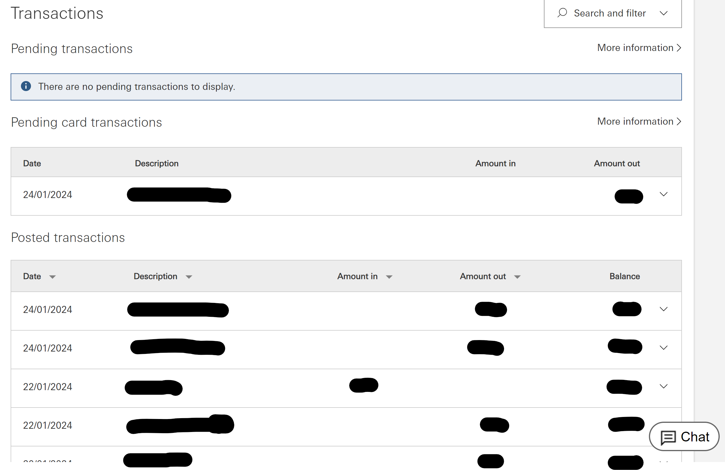

This is a clean layout for tracking transactions and the simplicity something I hope to replicate. Furthermore having pending transactions being able to be viewed and separated from the history. This will be useful in my database as it will allow students to view whether the money they have requested from house bank in cash has gone through. However I don’t think I will have amount out or amount in seperated and will probably just have + or – amounts displayed in transaction history

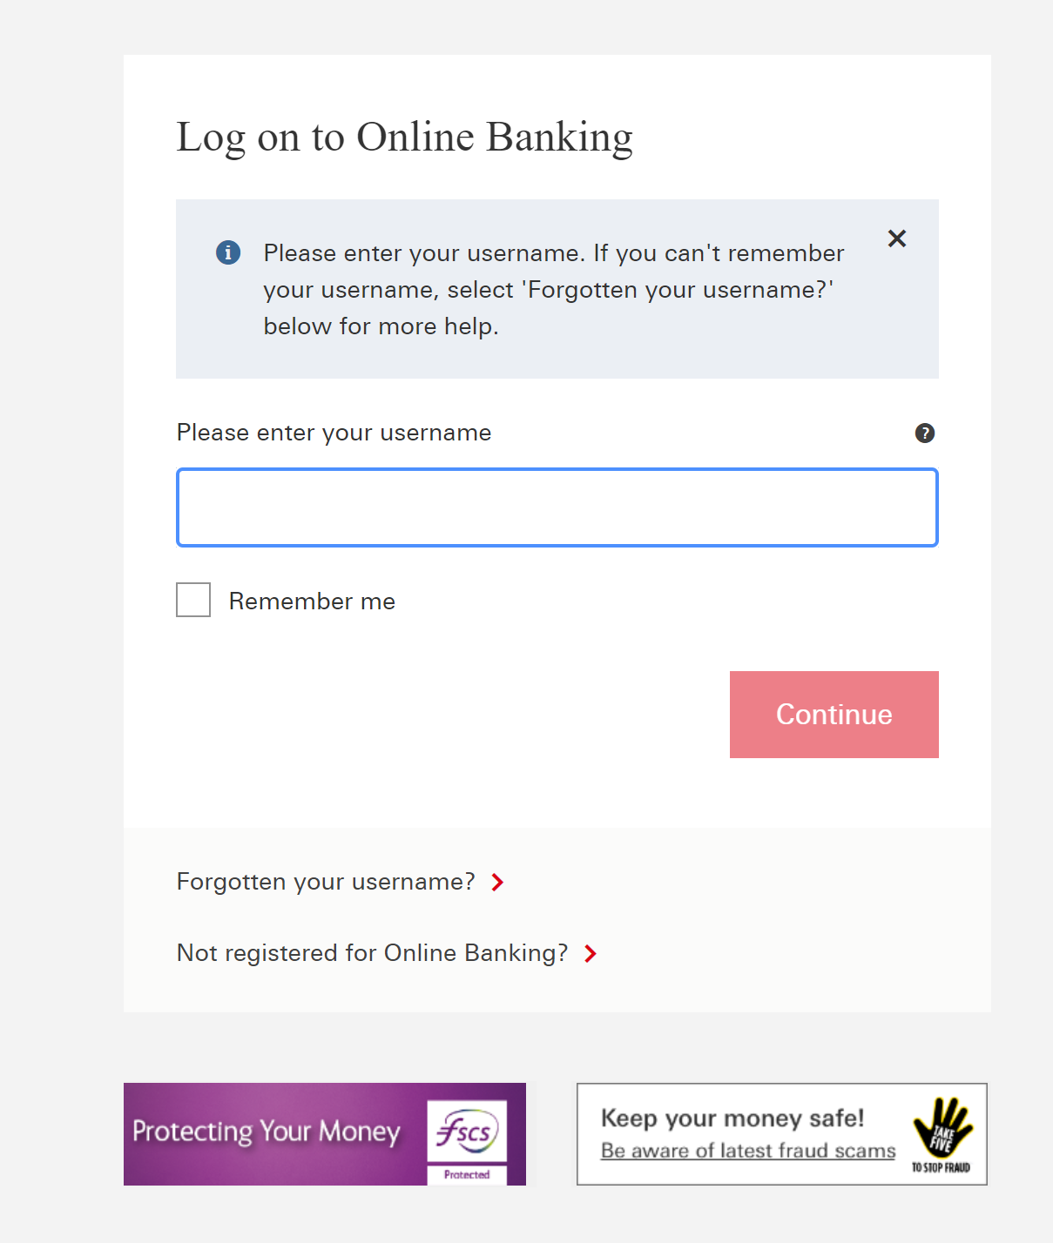

This specific online banking system uses usernames to allow users to log in to the system. This is better than the Barclays method as it does not relay on the device remembering the user. I will implement something like this in my database system.

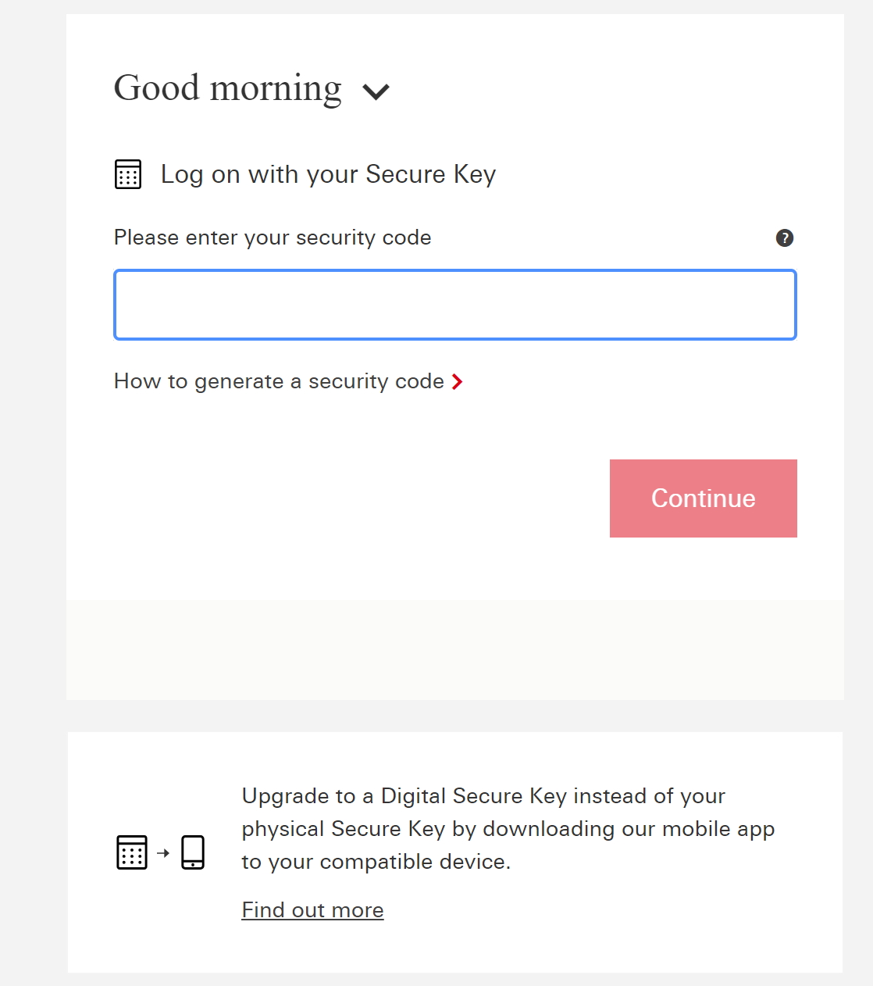

In HSBC and most online banks they require either a digital secure key generated by your phone or by a physical secure key. This is too complicated for my system so I don’t think I will be using this and will stick with a reusable password instead of a one time key that is sent to the user.

**Money Transfer**

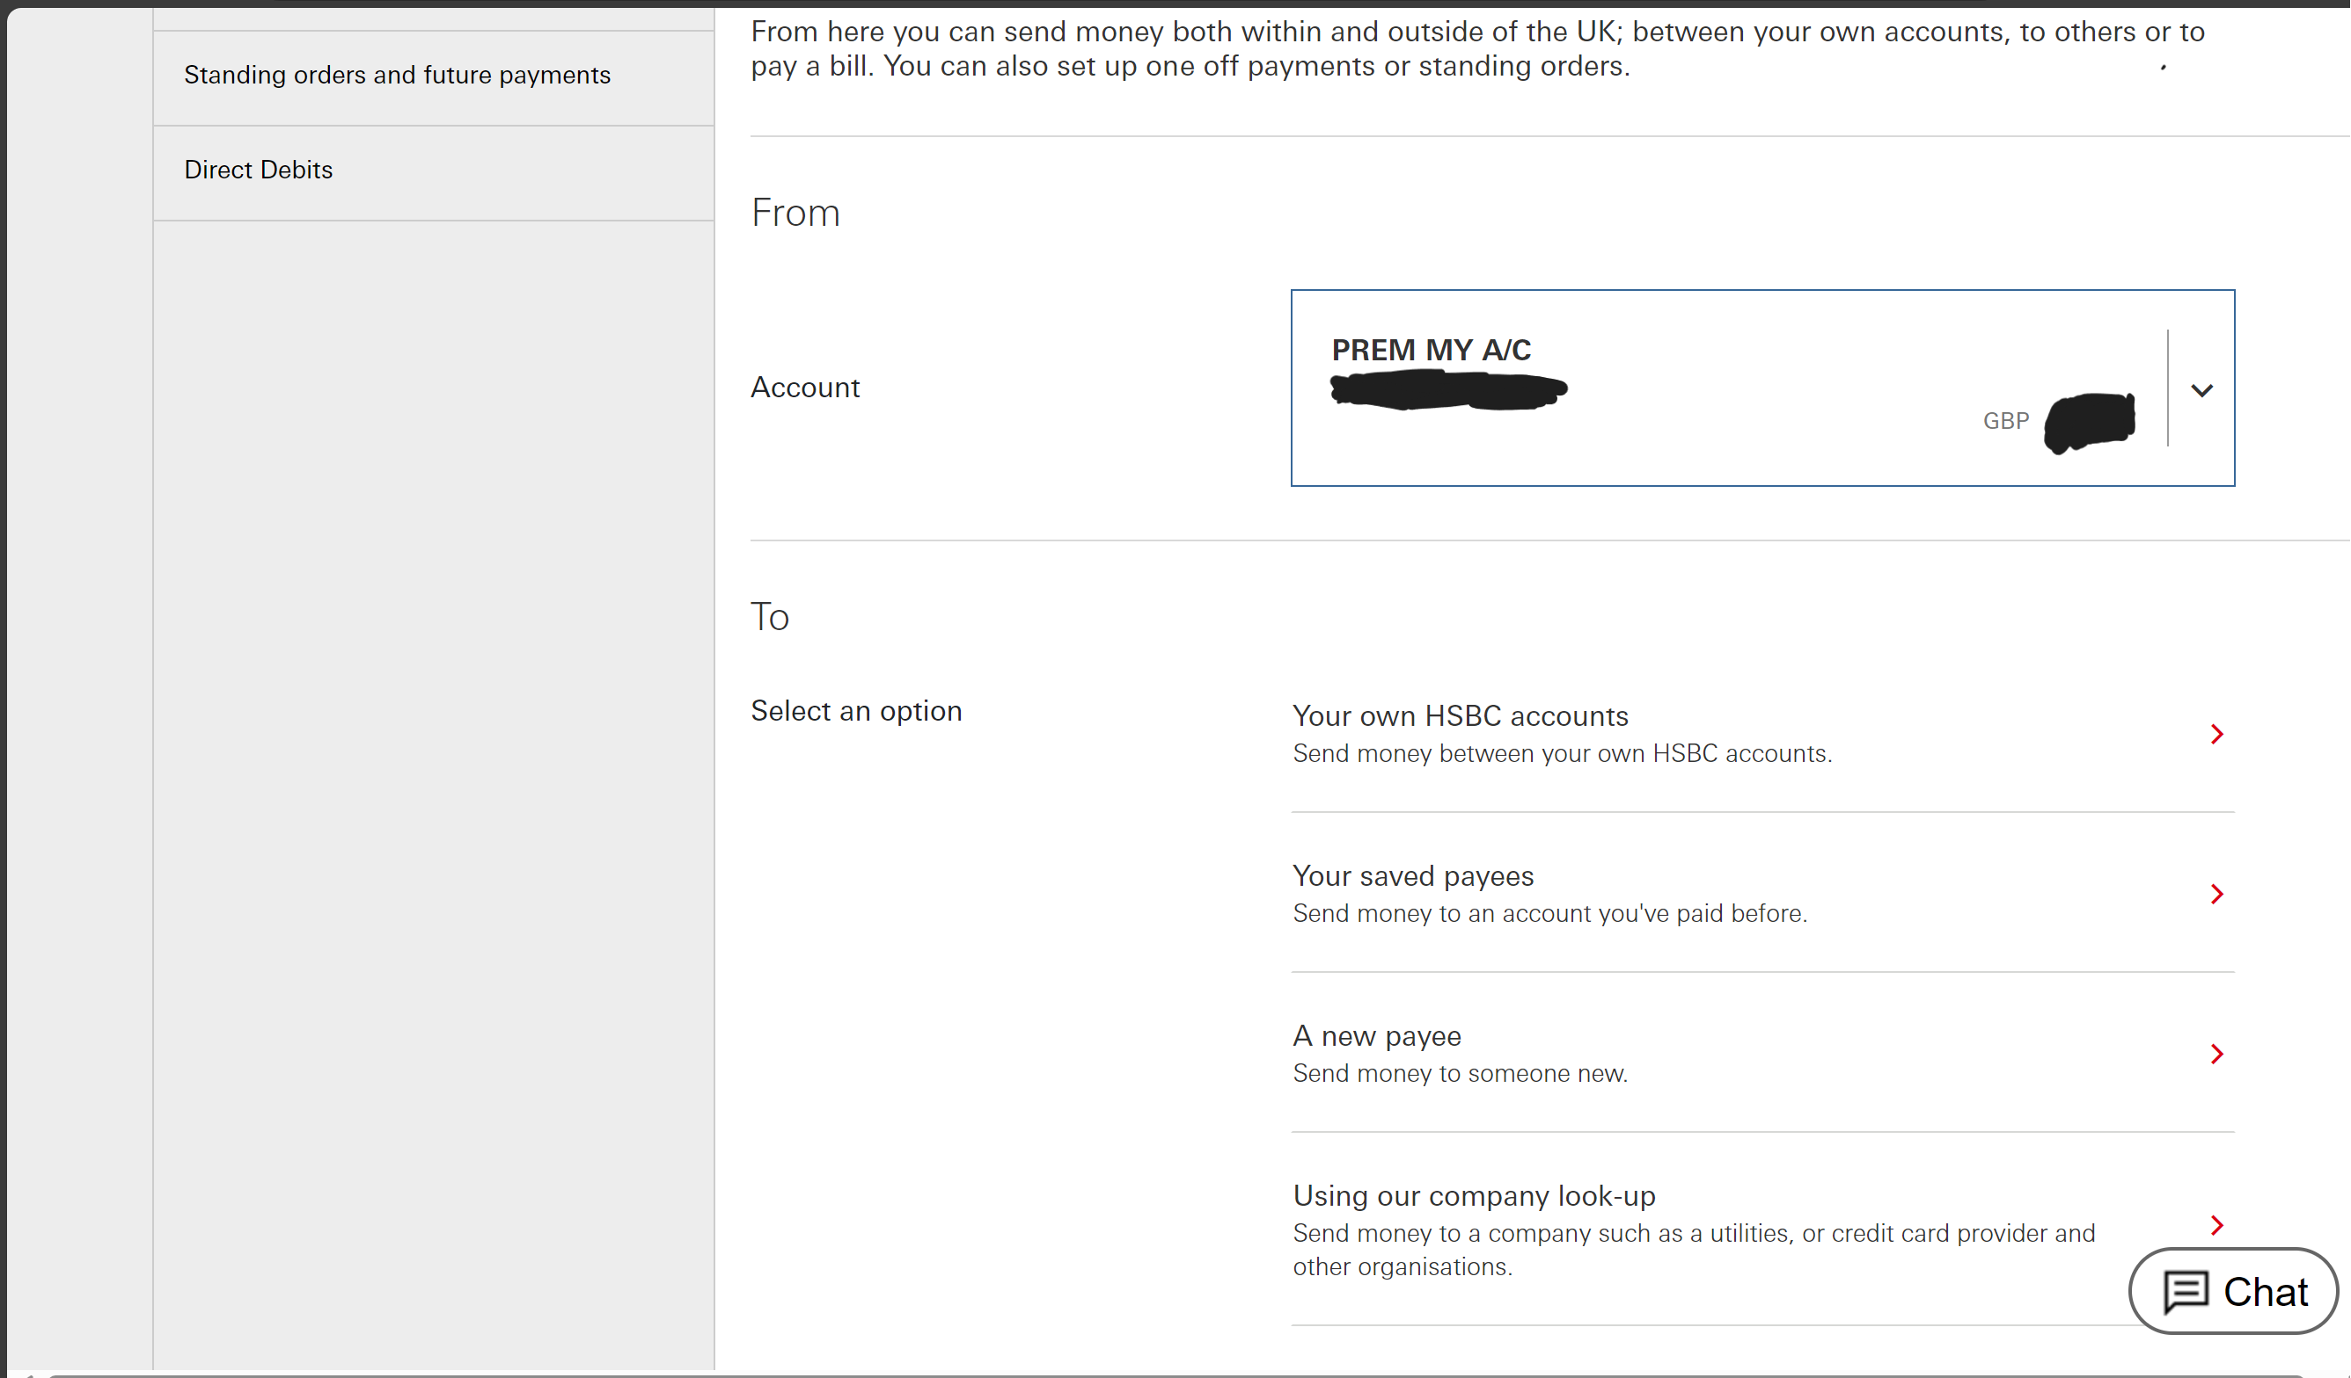

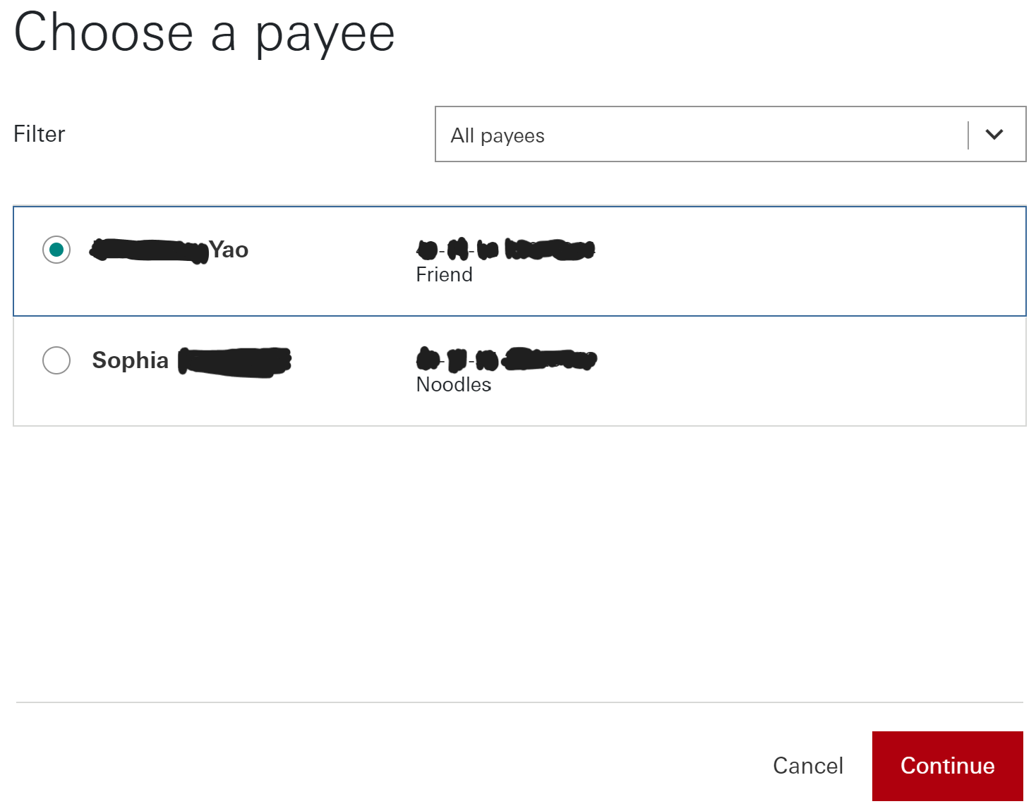

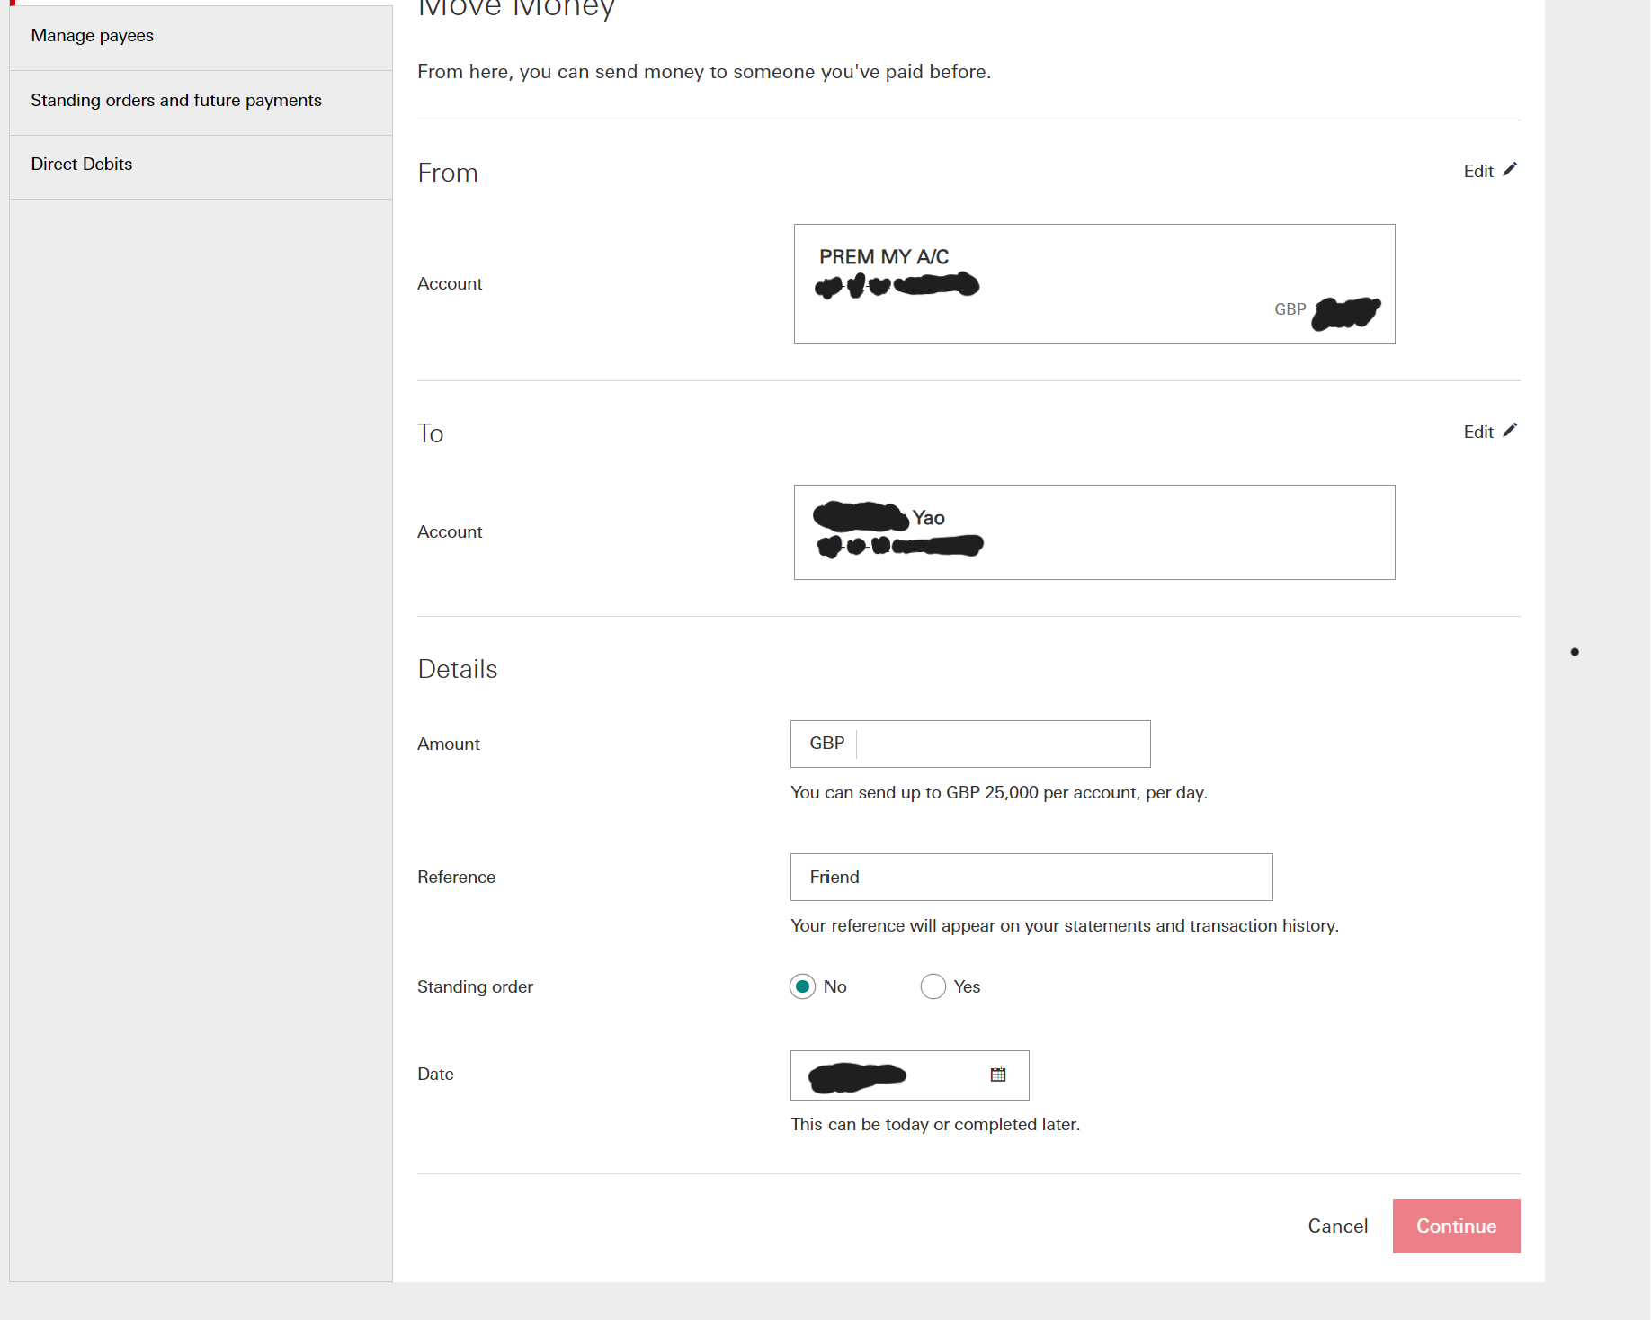

This money transferring system is very effective as it allows users to add a new payee or select a known one. This would be useful when a new set of students join a house as they can easily be added as new payees. Furthermore you can add a reference which will allow the reasons for money transfers to be listed in the transaction history

**Summary of HSBC online banking research**

* One thing that HSBC does very well is the payment system and is something that I wish to replicate. This is because it has a reference and a date that automatically inputs to the current date of the transaction. This would be a good system for tracking how students withdraw money from house bank.
* Another detail that I would implement is the username login system. This will allow pupils to login to the website to show their personal bank accounts.

### Similar Solution 3: PayPal.com

Looking at Paypal.com will give me another perspective of how I might layout my online

**Main Page**

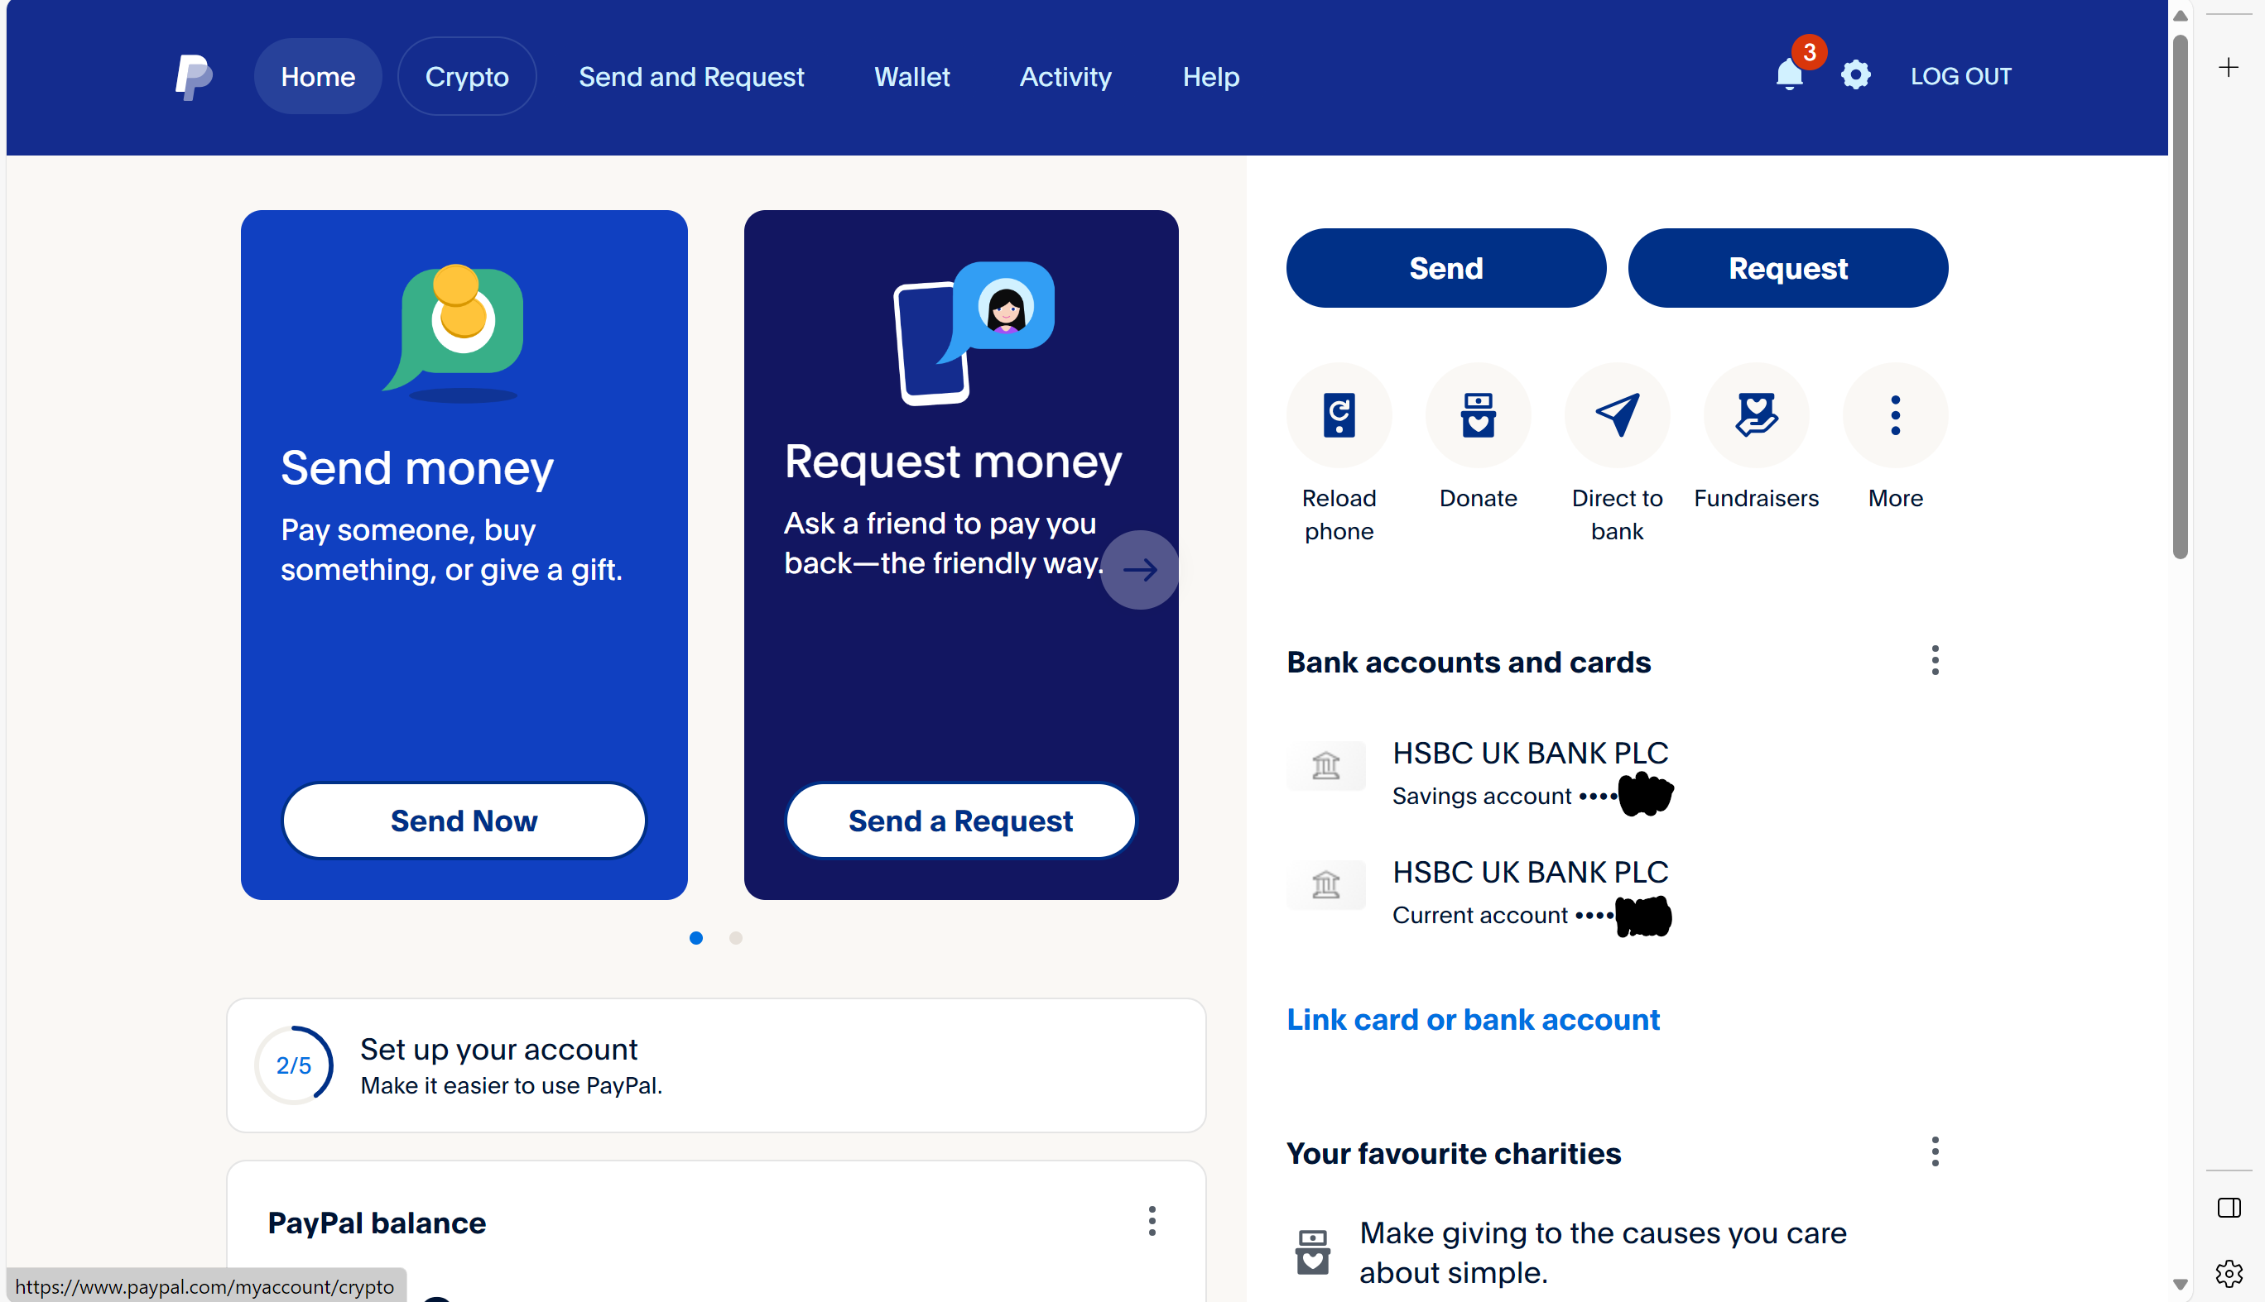

This main page is laid out very well. I like how the two main features of sending or requesting money is in the centre of the page. There is also a lot of useful information on the home page such as balance. I also really like the nav bar at the top the page because it is very simple but has all of the essential features. However the homepage is also cluttered with unnecessary features such as reload phone and fundraisers which are not features that I will be using in my database.

**Sending Money**

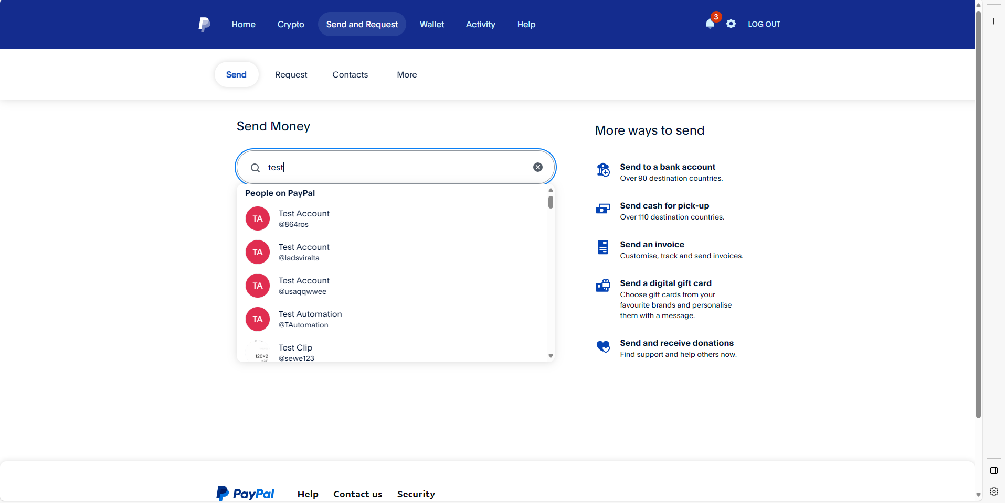

PayPal uses a search bar that allows users to search for other users to send money to. This is not something that I will be using as there are a very small amount of users that the admin needs to have access to as there are a maximum of only 60 students in Crosby.

**Wallet**

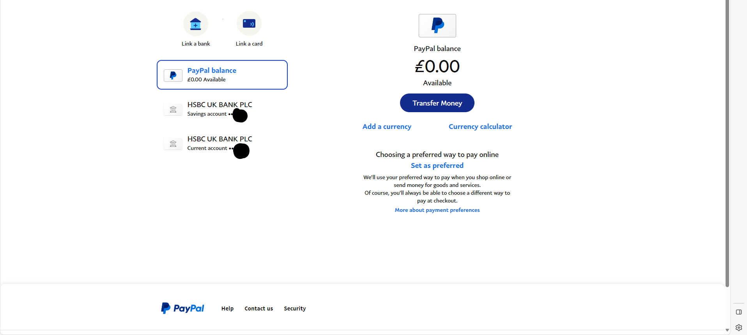

This is not a very good example of a wallet/balance page for my online house bank as there are multiple bank accounts that users have access to on the PayPal website, whereas the users in house only have access to one bank account. Also Crosby house bank will only be done in GBP so multiple currencies are unnecessary.

**Activity**

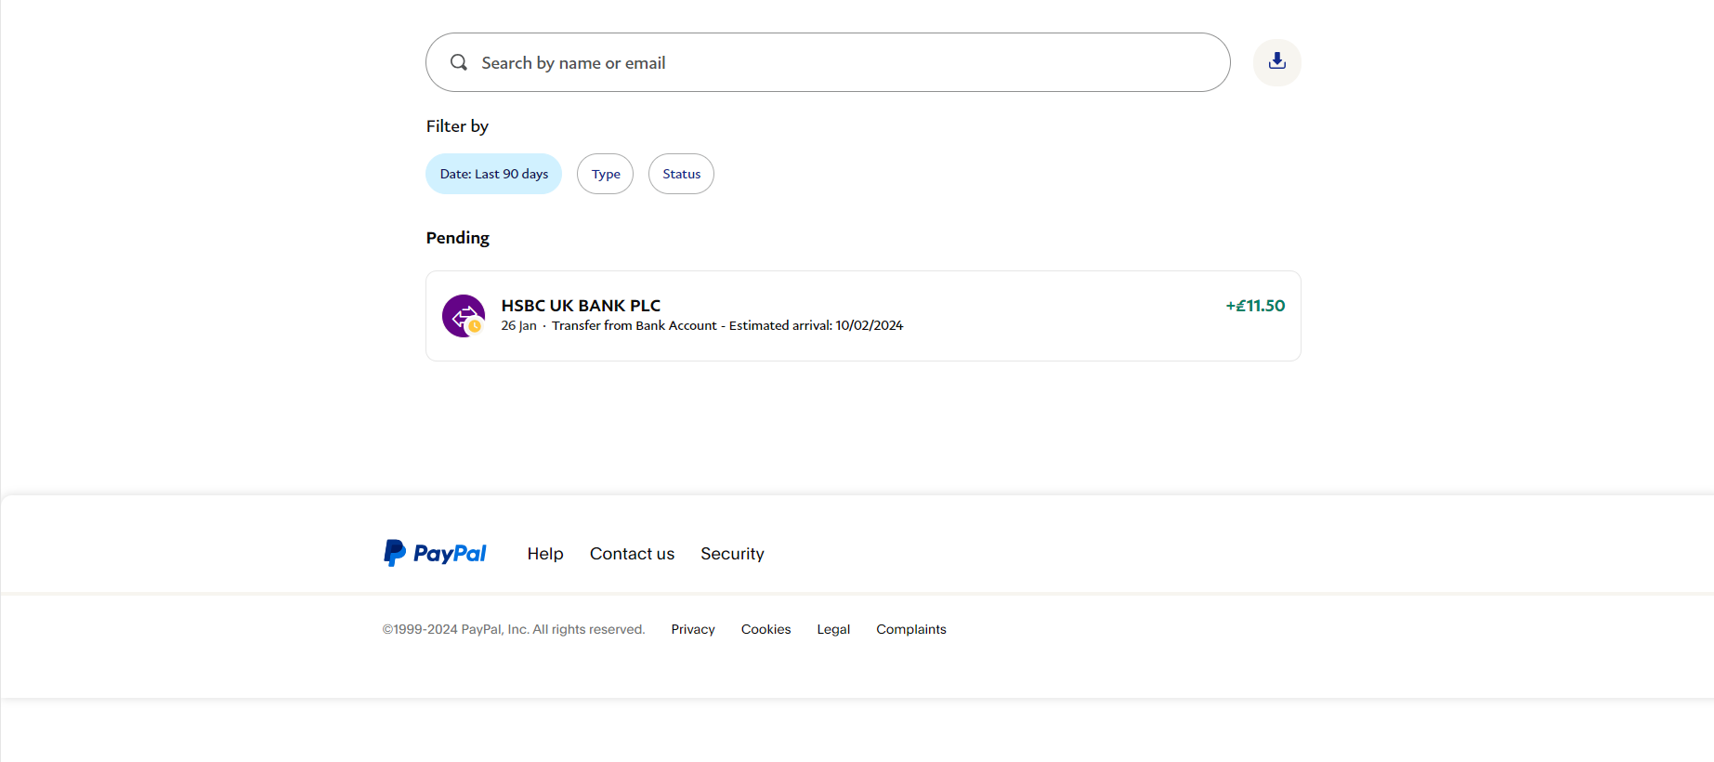

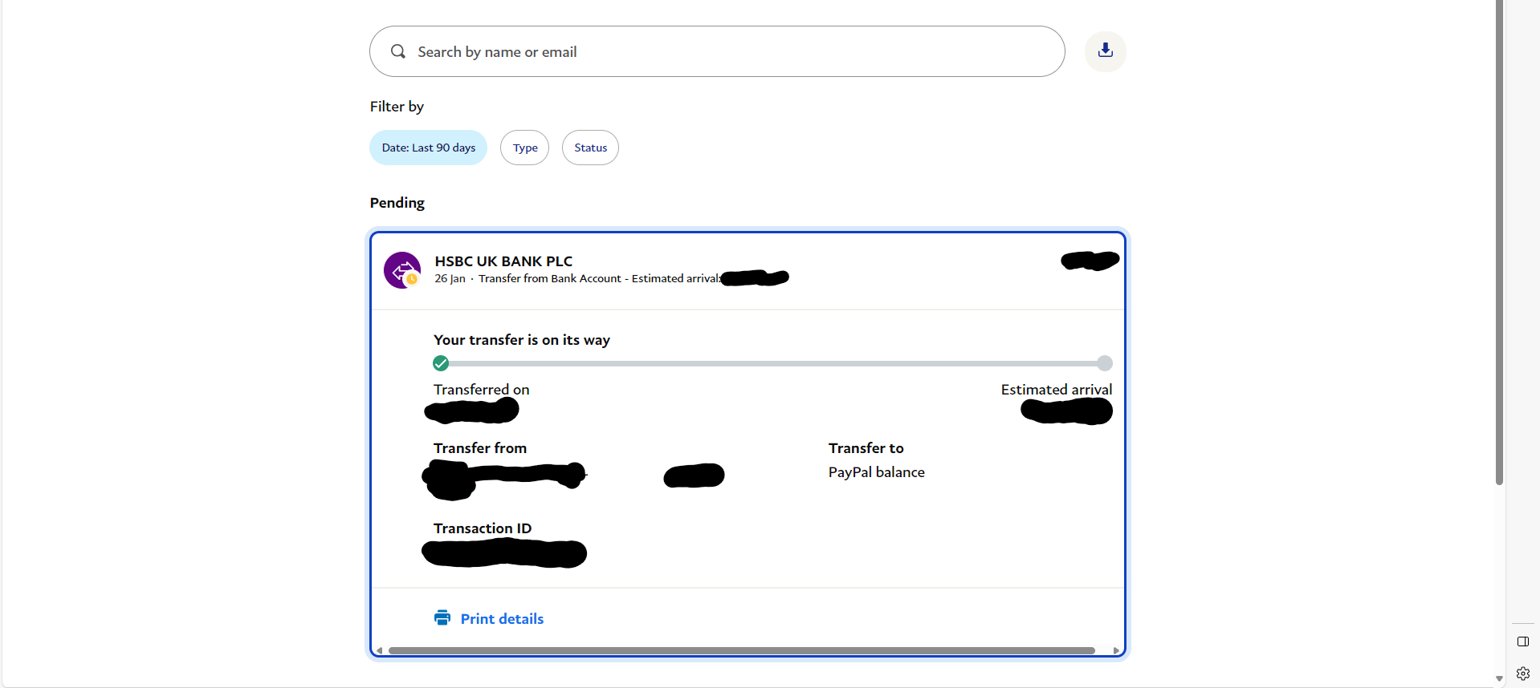

PayPal transactions have a search bar to search through transaction history which I will not be implementing into my database as it is unlikely that the student will have a large number of transactions which require a search bar to navigate. However I do like the dropdown of showing the details of each transaction as it makes the transaction history much tidier.

**Help**

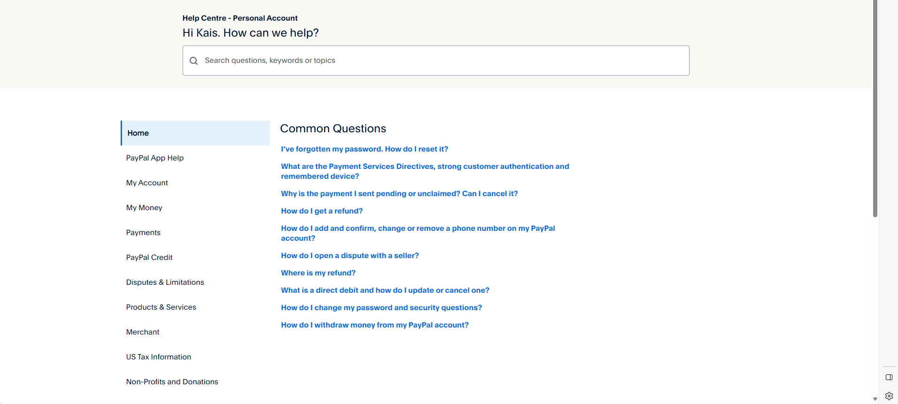

**Summary of PayPal analysis**

* Overall the layout of the PayPal is very appealing.
* One feature of PayPal that I would replicate is the ability to see all accounts that you can transfer. This would be helpful for viewing all of the students in the house and selecting the students account you wish to manage as the administrator.

### Similar Solution 4: Local ATM

Since my system is basically an ATM that is online, I thought looking at a real ATM and analysing the features would be useful to provide some ideas for features of my website.

**Main Page**

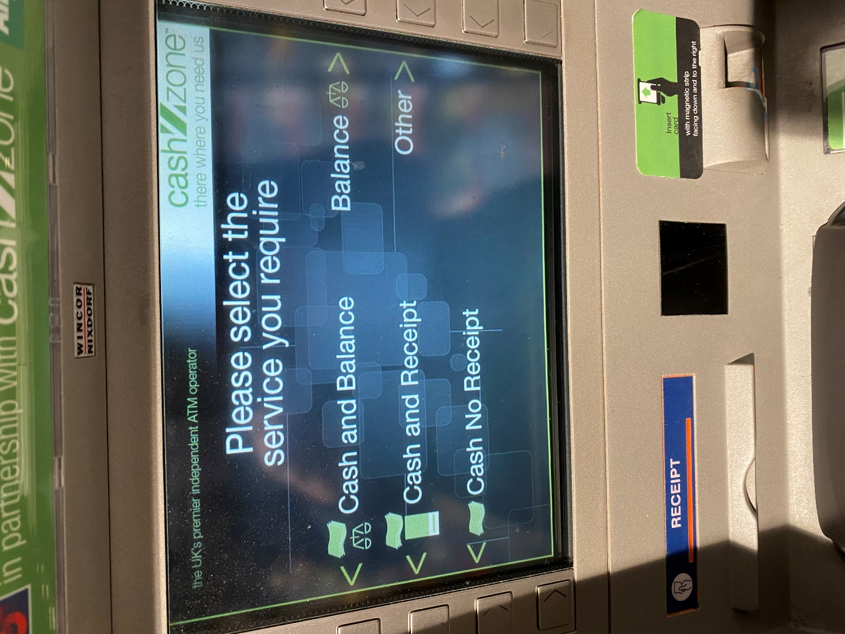

This is a very simple homepage. There are not many features which allows the layout of the homepage to be very simple. However since the ATM is controlled by buttons on the side instead of mouse and keyboard or touch screen it makes the user interface very different inputs on screen have to be in line with the side buttons. Also the colours are very un-appealing.

**Balance Page**

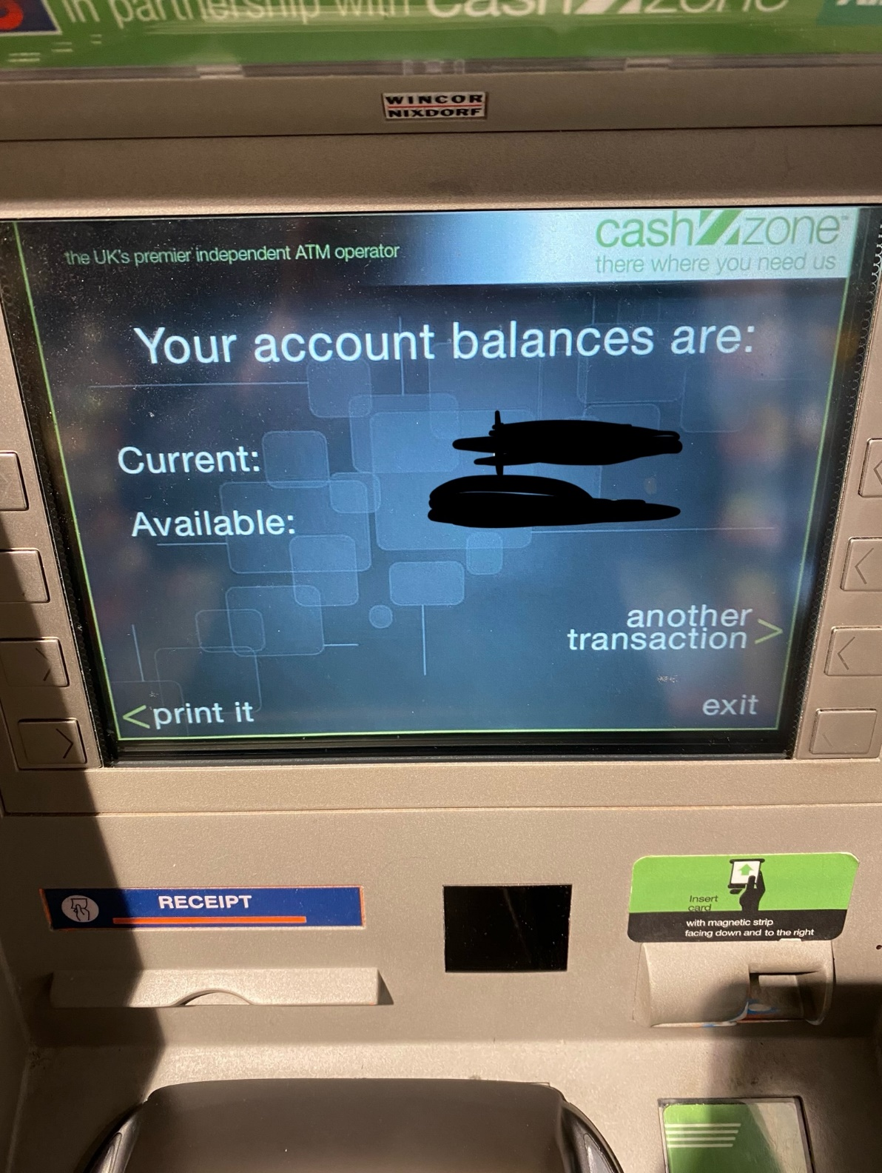

Very Simple. Not many features. Does not display transactions as it is not viewing personal bank account. My website will not have available or current balances. My system will also not have the ability to print the balance either.

**Cash Withdrawal Page**

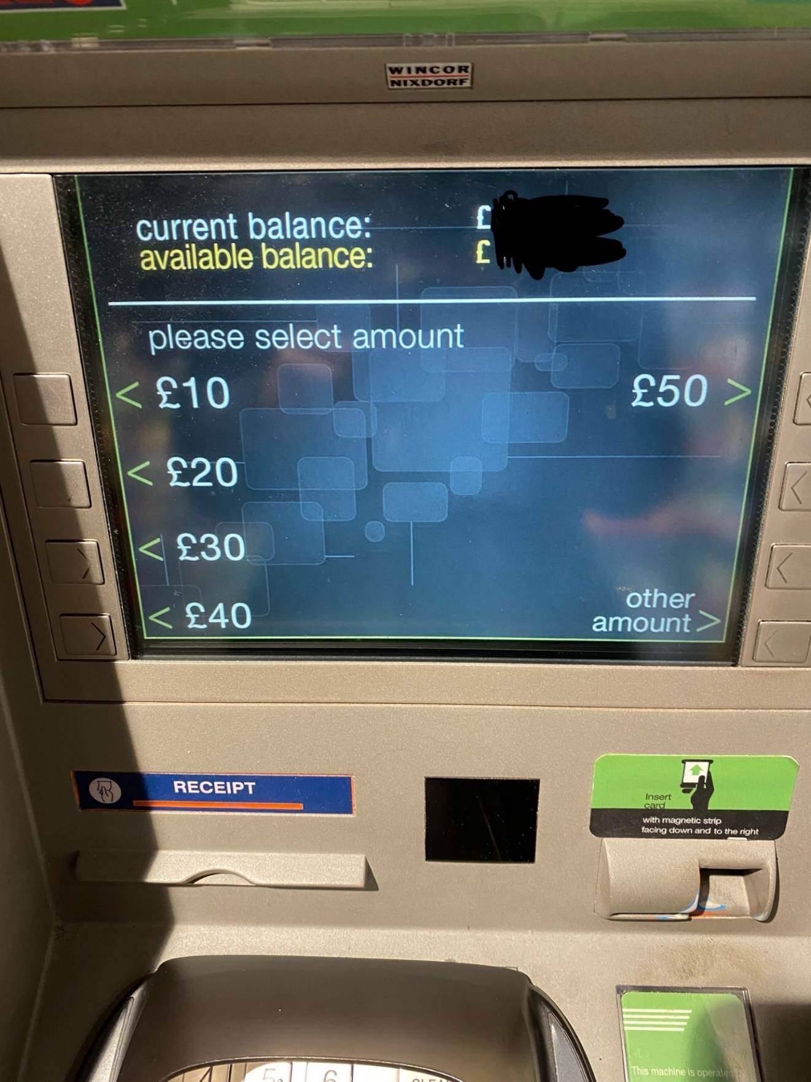

Only allows users to withdraw set amounts. Even when withdrawing other amounts users can only withdraw in multiples of ten which is quite impractical. In my database i hope to allow students to input any amount of money they wish to withdraw as long as it is a whole number.

**Other Services**

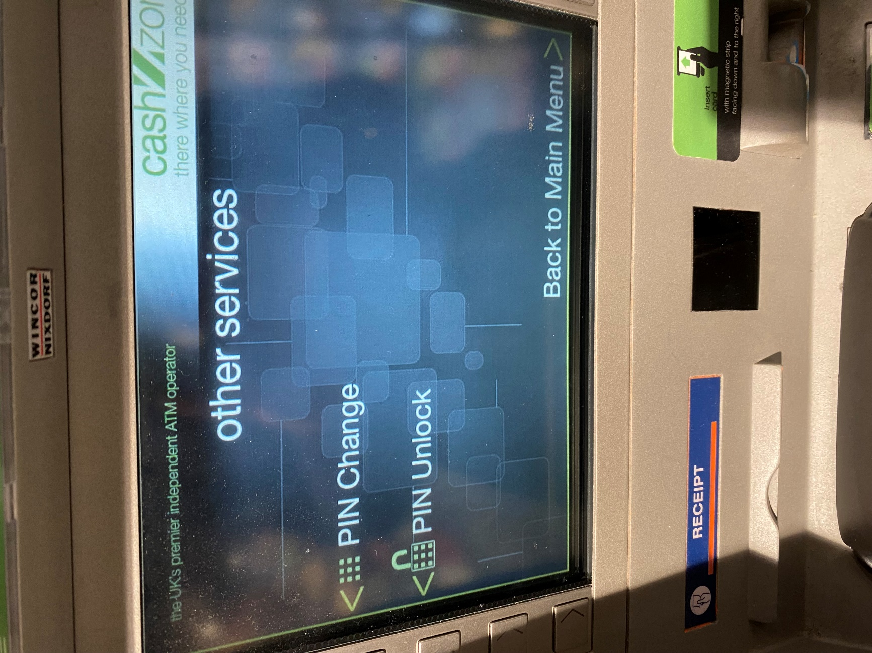

These services are completely unnecessary for the online house bank as the students and the administrator are not going to require PIN to access the website.

**Summary of ATM analysis:**

* Overall the ATM is very simple so there is not a lot of useful analysis. However it would be useful to replicate when viewing the money in house safe and house bank account as the money in the house safe is effectively the current available balance while the current balance is the money in the house safe plus the money in the house bank account.

## Hardware and Software Requirements

#### Hardware Requirements:

* The user should have access to any sort of computer that has access to the internet. For example a mac book or an iPhone. This is because the user needs to be able to access the website.
* I will be using my Microsoft surface Pro to code the website. This is because it is the standard issue computer that my school has given me so it has acess to all of the applications that I need to code my website.

#### Software Requirements:

* I will be using Visual Studio Code to write the code. I will be using this because it is one of the applications provided by the school. Also the program integrates very well with GitHub as it can easily push code straight from visual studio code. Furthermore the application makes using multiple coding languages very easy. It also has highlighting for the syntax of all of the popular coding languages which makes coding much easier. Additionally it is the application that I use to code the most so I am already very used to it.
* I will be using GitHub to upload my code to the cloud. This is because GitHub process of committing code straight from visual studio code is very convenient. Also GitHub allows for other users to access your code easily which makes it easy for my teacher to track my progress.
* I will be using XAMPP to code my web based database locally on my machine. This is because coding the website locally is much easier as my changes automatically get updated so I can check changes my changes or additions much easier rather than having to have my changes saved on an online server. XAMMP also allows me to use MySQL which is what I will be using to manage my database.
* I will be using Award Space to host my website once complete. This is because it is completely free to use and allows me to create a domain for free. Also it allows me to have 1gb of storage and a reasonable number of concurrent users which is more than enough
* Users will need either Microsoft edge or google chrome. This is because house bank will be a website online so they will need to acess it this way.

## Essential Features

* My website will have a login page that allows each pupil to login to view their account or allow the admin to login. This therefore prevents pupils from viewing other peoples bank accounts and separates students from the administrator.
* My website will allow pupils to view their transaction history as this is important to track money being withdrawn from house bank and money added to house back. The administrator will also be able to view student transaction history.
* My website will allow pupils to their own personal balance so that they can see how much money they have left in house bank if they need to add money to house bank.
* My website will allow pupils to put money into house bank and take money out of house bank while updating their personal balances as this will allow the house bank to function.
* The website will allow the administrator to view the current cash balance in the house safe. This is because the administrator needs to know whether they need to withdraw more money from the house bank account as cash in order to pay a pupil. The administrator will also be able to update the cash balance of the house safe.
* The website will also allow the administrator to view and update the house bank account. This will allow the administrator to see how much money they can withdraw from the bank account.
* My Website will allow students to view a graph of their house bank balance over time. This is essential as it will allow the students to visualize their spending habits in house bank.
* My website will allow the admin to view a graph of all of the student balances in house bank over time as well as each individual students balance over time. This is essential as it will allow the admin to see which of the students are spending excessive amounts or which of the students are not using house bank much at all.
* The administrator will also be able to manage and view every students bank account. This will allow them to see if a student is in debt so that they can notify them.

## Limitations

* The Crosby House bank system will not be linked to actual bank accounts or have any sort of credit card system to transfer money into house bank. This is because it would be too complicated for me to set and testing whether the system is risky especially if using real bank account or credit card details as incorrect amounts of money could be charged to them which would cause large problems. Also the purpose of house bank is too keep cash safe so that it can be withdrawn at a later date. Therefore having bank transfers would defeat the purpose of house bank.
* I will also not be including any sort of SSL security. This is because it is unnecessary as the house bank account system will not contain any sensitive information and will only contain balance numbers. Furthermore, there is also a very low risk of the system being hacked. However, the passwords for the login system will be hashed. Also the high profile SSL security from third party sources is sometimes quite expensive.
* The website will also not allow users to transfer money in between bank accounts. This is because house bank is not meant to be for students to pay each other it is only about keeping large amounts of money in a safe place so having users transfers being able to pay each other is not a necessity.
* Also there will be no automatic updates to either the students or the administrator alerting whether a student has come into debt. This is because these updates could become disruptive and repetitive. Also would be quite hard to implement as it would require using with an external system such as outlook to set up or integrating into windows operating system.
* Another limitation would be the number of users that the system will support. This system will be capped at 70 users. This is because the number of people in Crosby is a maximum of 60 people and is most of the time below this number due to students leaving house. Therefore there is absolutely no situation in which there would need to be more than 70 users and allows for a few extra users if the house expands.

## Success Criteria

1. **Users and Administrator login:** The system will allow at least 5 general and 1 administrator to login to the system with a user name and password. This is to ensure the login system works properly.
2. **Add Users:** users must be added to the system. This is because when people join house they must be added to the system. This must only be able to be done by the administrator
3. **Remove Users:** This is because pupils need to be removed when they leave the house. This must only be able to be done by the administrator.
4. **Hashing Password:** The student and administrator passwords will be hashed when stored. This is to ensure they are kept safe and cannot be intercepted if the system is hacked.
5. **Pupil view Account balance:** Each of the 5 users must be able to view the amount of money in their house bank account. This is because the students need to know how much money is in their account. Also they must not be able to view
6. **Administrator View Pupil Account balance:** The administrator must be able to see the account balance of each of the pupils to see whether they are in debt
7. **Drop Down List for Administrator:** The administrator must be have a drop down list of all of the pupils in the house which he can select a pupil from to view their balance. This will make it much easier for the admin to check all of the student balances.
8. **Withdraw money from house bank:** The students must be able to withdraw money/ request money to be withdrawn from their house bank account balance.
9. **View Transaction History:** Students must able to view their transaction history of all of the money they have withdrawn or deposited into house bank in the past. The administrator must also be able to view each of the students transaction history.
10. **View a graph of spending:** All students must be able to see a graph of their own individual house bank balance over time. The Admin must be able to see each of the students individual graphs as well as a graph of all of the students.
11. **Withdrawal Request Alert:** the administrator must be alerted on the website when the student has withdrawn money from house bank so that they can be paid.
12. **View House Bank Account Balance:** The administrator must be able to view the house bank account balance to see how much money can be withdrawn in cash
13. **View House Safe Amount:** The Administrator must be able to view the amount of cash in the house safe to see if more money needs to be withdrawn from the bank account.
14. **Update House bank account Balance and House Safe amount:** The administrator must be able to update the amount of money in the house bank account or safe.
15. **Automatically Update House Safe amount:** When money is withdrawn from the house bank account both the house bank account and house safe amount will update. When a student deposits money in house bank the house safe amount will also increase. This is because the students cash has been added to the house safe
16. **Student Debt:** Students on the house bank website will be alerted with a red message when they enter debt. This is to ensure that they can then pay the money back when the end of the year comes.

# Design

### Entity Relationship Diagram

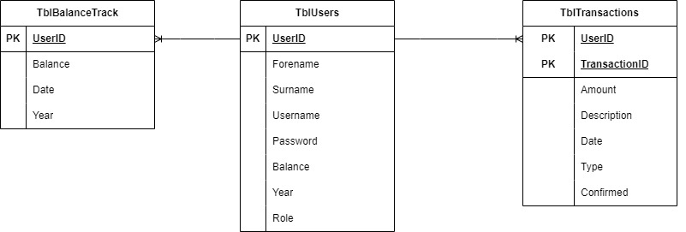

### Justification of Entity Relationship Diagram

The TblUsers is required to store all of the pupils personal details such as their name that will be displayed when they login. It will also store the username and password details that the students will use to login to the house bank database. Furthermore the students house bank balance will be stored in the user table. The Role variable will differentiate the pupils from the administrator so that only the administrator can edit the database.

The TblTransactions will store the details of each of the students withdrawals of deposits . This will be done using the amount variable to show how much the students is withdrawing or depositing. The User ID and transaction ID will be combined to make the primary key so that each transaction can be assigned to a specific user. The description will be optional if the user wants to provide context to their withdrawal to make it easier to remember. Descriptions will not be required for deposits as students do not normally have a reason to deposit money in house bank.

The TblBalanceTrack will be used to track how each of the students balances changes overtime. This will be used to generate graphs that can be used to analyse student spending.

## Tables

### TblUsers

|  |  |  |  |  |
| --- | --- | --- | --- | --- |
| **Field Name** | **Data Type** | **Validation** | **Typical Data** | **Justification** |
| UserID | INT(3) Primary Key | Must be 3 digit auto generated code | 12 | Unique Identifier for each of the students in the house and the administrator. Also used as a username when logging into the system |
| Forename | Varchar(30) | Required(Presence Check) | Hector | To identify users |
| Surname | Varchar(30) | Required(Presence Check) | Bass | To identify users |
| Password | Varchar(30) | Hashed(presence Check)(default to “Password”) | password | To allow users to login securely |
| Username | Varchar(30) | (presence check)Must have . in the name(format check) | Bass.h | To store |
| Balance | Decimal(6,2) | Must be greater than equal to zero(Range Check) Default to zero | 300.50 | To show how much money the user has in their house bank account |
| Year | Varchar(10) | Can only be Third, Fourth, Fifth, Lower, Upper or Admin(presence check) | Third | To show what year group the student is in |
| Role | Tinyint(1) | Default to zero( number zero represents pupil)  (1 represents admin) | 1 | To differentiate between administrator and user so that only administrator has privileges |

### TblTransactions

|  |  |  |  |  |
| --- | --- | --- | --- | --- |
| **Field Name** | **Data Type** | **Validation** | **Typical Data** | **Justification** |
| UserID | INT(3) Primary Key | 3 digits autogenerated | 123 | Unique identifier for each of the users |
| TransactionID | Int(5) Primary Key | 5 digits autogenerated | 23122 | Unique identifier for each of the transactions |
| Date | Date | Required(Presence check) | 08/03/2024 | Displays the date of when the transaction was made |
| Amount | Decimal(6,2) | Required: Must be greater than zero. | 50.50 | States the amount that the student either withdrew or deposited into house bank |
| Description | Varchar(40) |  | Taxi Ride | Allows for users to provide a short description of what they withdrew money for so that if they want to check what they withdrew money for they can be reminded by the description |
| Type | Tinyint(1) | Default to zero(Deposit money) | 1 | To differentiate to whether the transaction is a withdrawal or a deposit. |
| Confirmed | Boolean | Required(Presence check) Default to FALSE | True | This will allow for transactions to be confirmed as to whether or not the money has been given to the student or whether the student has given money to the admin. This will be updated by the administrator |

### TblBalanceTrack

|  |  |  |  |  |
| --- | --- | --- | --- | --- |
| **Field Name** | **Data Type** | **Validation** | **Typical Data** | **Justification** |
| UserID | Int(3) Primary Key | 3 digits autogenerated | 001 | Unique identifier for each of the users |
| Balance | Decimal(6,2) | Required Must be greater than zero | 50.50 | Allows to follow changes in the students balance. This will essentially take a copy of the students balance after a transaction |
| Year | Varchar(10) | Can only be Third, Fourth, Fifth, Lower, Upper or Admin | Third | To show what year group the student is in. This is used to generate year group specific graphs |
| Date | Date | Required(Presence check) | 08/03/2024 | Displays the date of when the transaction was made |

## Top Down Design

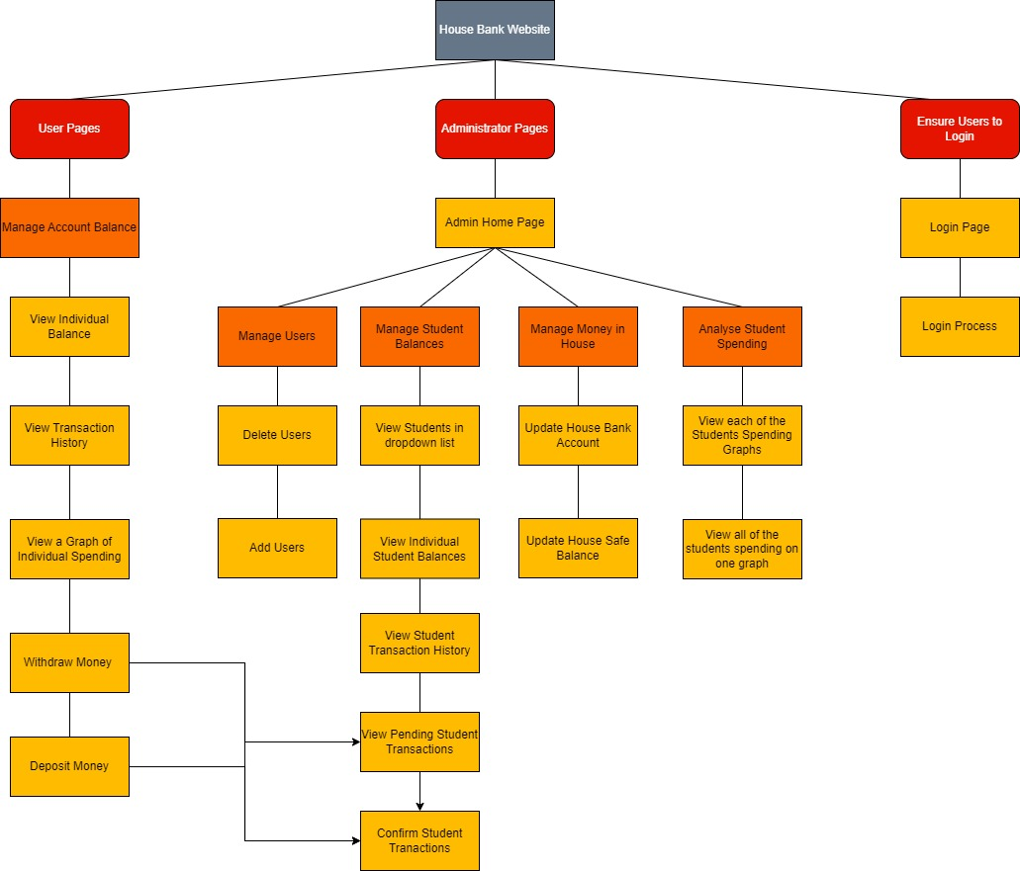

#### Justification for Top down design

The three bright red sections are the three sections of the website. The login part of the website is needed to differentiate pupils from the administrator and to ensure that pupils will only be able to access their own balances. The login page is required to have users input their login details. The login process page is then required to process the login details and check if they are correct. It will also check if the user logging in is a administrator or a pupil.

The administrator will have a home page to allow them to navigate through all of the administrator features. The orange bubbles state each of the individual features for the users. For the administrator manage users is a required feature as they are in charge of updating the different users in the house as people leave and join. This will therefore need to be done by allowing the admin to add or delete users. The delete users page will be done by having a page of all of the users with delete buttons next to all of the users because this is the most efficient of deleting users. The add users page will be done separately. The administrator will need to manage student balances because they need to check whether students are in debt. The student dropdown list is required to allow the admin to select which students individual balance they want to view. The viewing student balances and transaction history is also required to check if a student is in debt and to remind them of the students past transactions. Manage money in house means the administrator will need to manage the houses money. Therefore there will be a dedicated page to allow the administrator to update the amount of money in the house safe as well as the house bank account.

The user pages mainly will need to allow the students to manage their own individual balance. Therefore the students will need to have main page that displays their transaction history and their current account balance. From this main page students will be able to withdraw money and deposit money which will take them . These will only be requests as the online house bank will not be a real banking system. Therefore the admin will have to see the current pending transactions and then confirm as to whether the students have received their cash or not or if the students are depositing money the admin can confirm whether the student has given the to house bank.

## Draft Page Design

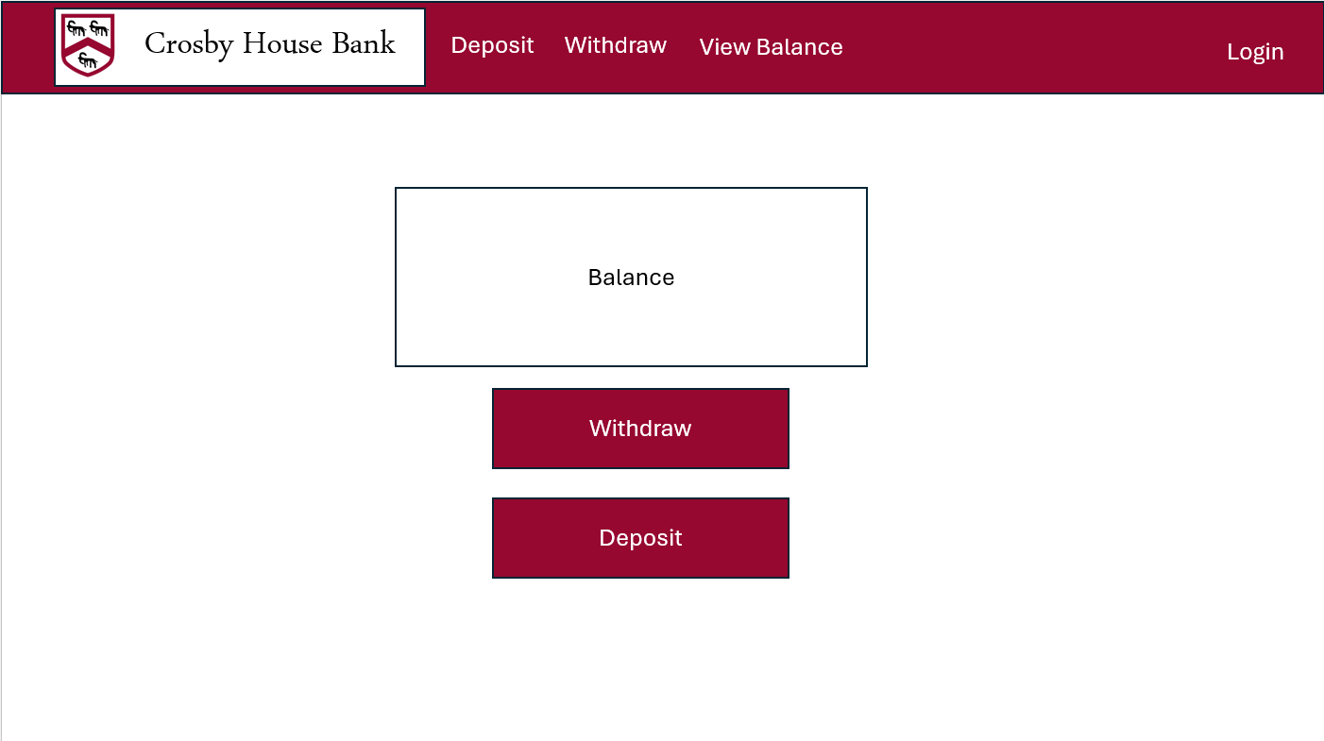

**Hex Colour Codes**

Tyriann Purple Theme(**#98022C**)

White Background(**#FFFFFF**)

Black Background(**#000000**)

**Fonts(PowerPoint)**

Title: Arabic Typesetting

Body Text: Aptos Body

**Usability Features**

There is a nav bar that will remain at the top of the page on every page. On the nav bar it will allow students to view their balance, deposit money and withdraw money. The login button will be on the far right side of the navbar so that it stands out.

All of the main text will be in Aptos body as it is easy to read. All of text will either be black text on the white background or white text on red background as it will also improve legibility.

All of the buttons on the page will be Tyrian purple to match the theme of Crosby house. Also all of the buttons will be labelled with their purpose so that users can navigate the site easier.

## Test Data

### Users

Admin:

UserID:1

Forename: Admin

Surname: Admin

Username: Admin.a

Password: Password

Balance:0

Year: Admin

Role: 1

This will be the test administrators details to ensure that all of the login system functions work correctly for the administrator. It will also allow me to test all of the administrator functionality. The balance is zero as the administrator does not need to have money in house bank.

First Test User:

UserID: 2

Forename: test1

Surname: test1

Username: test1.t

Password: Password

Balance: 150.50

Year: Third

Role:0

Second Test User:

UserID: 3

Forename: test2

Surname: test2

Username: test2.t

Password: Password

Balance: 200.50

Year: Third

Role:0

Third Test User:

UserID: 4

Forename: test3

Surname: test3

Username: test3.t

Password: Password

Balance: 100.50

Year: Fourth

Role:0

These three test users will allow me to test the login functionality for the students it will also allow me to check whether the individual balances can be seen by the users and that the administrator can view each of the users balances. The balances must be different to ensure that the right data is being provided to each user. It will also provide some data that will be displayed on the graph for the administrator. It is helpful to have two test users in the same year so that year group specific data can be analysed.

### Transactions

**First Test Transaction:**

UserID:2

TransactionID:1

Amount:15.00

Date: 17/05/2024

Type: 1

Confirmed: False

**Second Test Transaction:**

UserID:2

TransactionID:2

Amount:15.00

Date: 18/05/2024

Type: 0

Confirmed: False

**Third Test Transaction:**

UserID:3

TransactionID:3

Amount: 30.00

Date: current date

Type: 1

Confirmed: False

**Fourth Test Transaction:**

UserID:4

TransactionID:4

Amount: 23.00

Date: current date

Type: 0

Confirmed: True

**Fifth Test Transaction:**

UserID:2

TransactionID:4

Amount: 30.00

Date: 19/05/2024

Type: 1

Confirmed: True

The first two test data will be needed to check that money can be deposited and withdrawn from a student account. The third test data will be erroneous using a negative value for the transaction does not work or that an error message is displayed correctly. For all transactions the date will be done using the current date function as that will need to be the date associated with the transaction. The fourth test is used to check that another users balance can be updated and that the confirmation system also works. The fifth will be used to check that the graph can properly be generated by having three different transactions that can be plotted on a graph as data points.

### Balance Track

**First Test:**

UserID: 2

Balance: 200.50

Date: 16/05/2024

Year: Third

**Second Test:**

UserID: 2

Balance: 185.50

Date: 17/05/2024

Year: Third

**Third Test:**

UserID: 2

Balance: 200.50

Date: 18/05/2024

Year: Third

**Fourth Test:**

UserID: 2

Balance: 170.50

Date: 19/05/2024

Year: Third

**Fifth Test:**

UserID: 2

Forename: Nick

Surname: Cheep

Balance: 260.50

Date: 17/05/2024

Year: Fourth

**Sixth Test:**

UserID: 5

Balance: 200.50

Date: 18/05/2024

Year: Fourth

**Seventh Test:**

UserID: 5

Balance: 180.50

Date: 19/05/2024

Year: Fourth

These Test data will be used to generate graphs of the students transactions plotted against time for individual students on their balance page. The test data will also allow for multiple lines to be plotted on the same graph as well as year group specific graphs.

## Detailed Page Design

### Login Page

**Page Overview**

This is the page responsible for allowing users to login. Included in this page design will be the login page and the login process page as the login process page will be a separate page but will not be visible.

**Page Design**

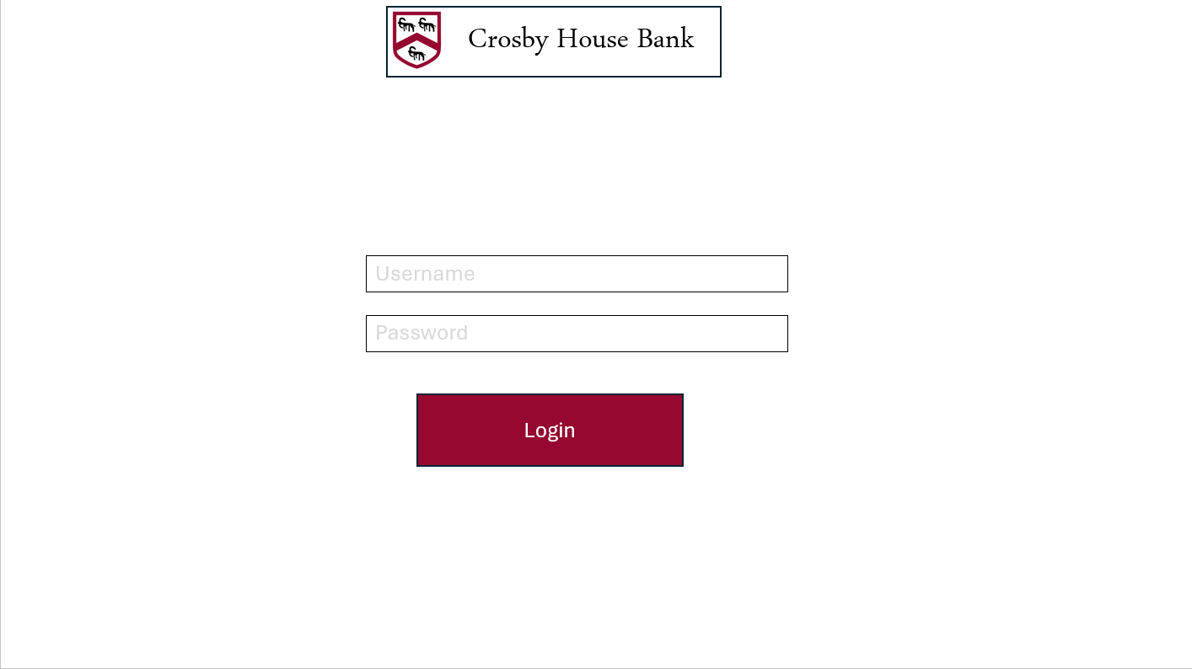

**Usability features:**

Buttons will be labelled clearly with their purpose and the colours will match the theme of Crosby house.

**Tables:**

* TblUsers

**Variables:**

* Post: Username
* Post: Password

**Validation:**

As per table designs

**Algorithms:**

Input Username

Input Password

If Username matches username in database:

If Password Matches Password in database:

If User is an administrator:

Send to admin home page

Else:

Send to pupil home Page

Else:

Print(error message)

Else:

Print(error message)

**Justification:**

This algorithm is responsible to check whether the users login details are correct and send them to the correct page whether they are an admin or a user.

**Test:**

User test data

### Student Home Page

**Page Overview**

This is the home page for students. It will show the students balance and their transaction history as well as a graph of their spending over time.

**Page Design**

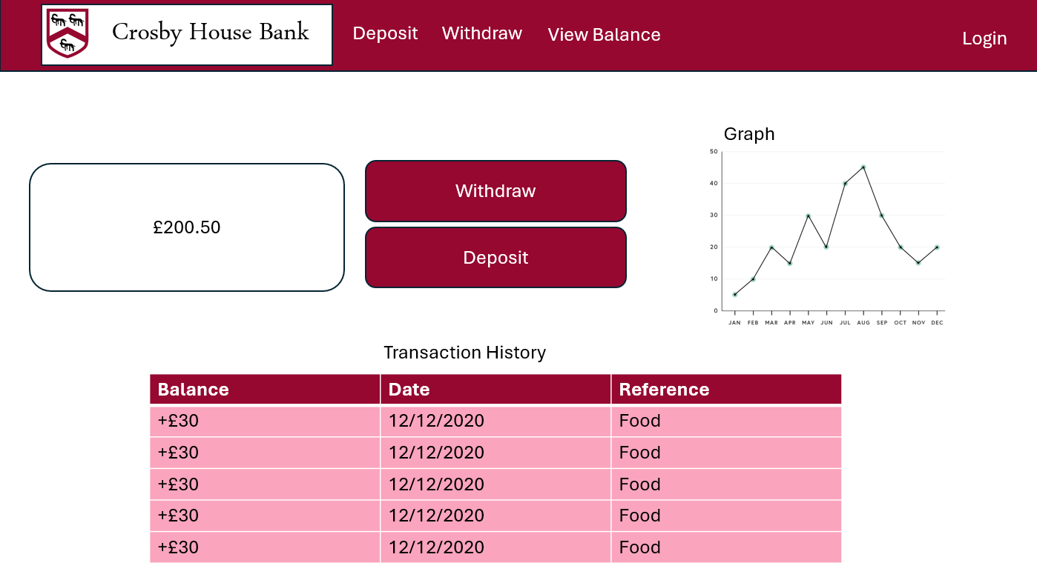

**Usability features:**

* Buttons will be labelled clearly with their purpose
* colours will match the theme of Crosby house.
* Nav Bar at the top of the page to allow students to navigate easier
* Font is easy to read
* Page is layed out in a neat manner

**Tables:**

* TblUsers
* TblTransactions
* TblBalanceTrack

**Variables:**

* Session: Username
* Session: UserID

**Validation:**

As per table designs

**Algorithms:**

To find the students balance:

SELECT Balance FROM TblUsers WHERE :username LIKE Username

To find the students transaction history

SELECT Balance, Date, Description FROM TblTransactions WHERE :userID LIKE UserID

To generate the graph:

SELECT Balance, Date FROM TblBalanceTrack WHERE :userID Like UserID

**Justification:**

The first algorithm will be used to display the students balance on the page, the second algorithm is responsible for displaying the students transaction history on the page. The third algorithm will be used to generate the graph that will be generated on the page of the students balance plotted against time.

**Test:**

User test data

Transaction Test Data

Balance Track Test Data

### Student Withdraw Page

**Page Overview**

This is the page the students will see when they want to withdraw money. In the actual project this will be split into two pages but the second page will be a blank processing page so I combined the two.

**Page Design**

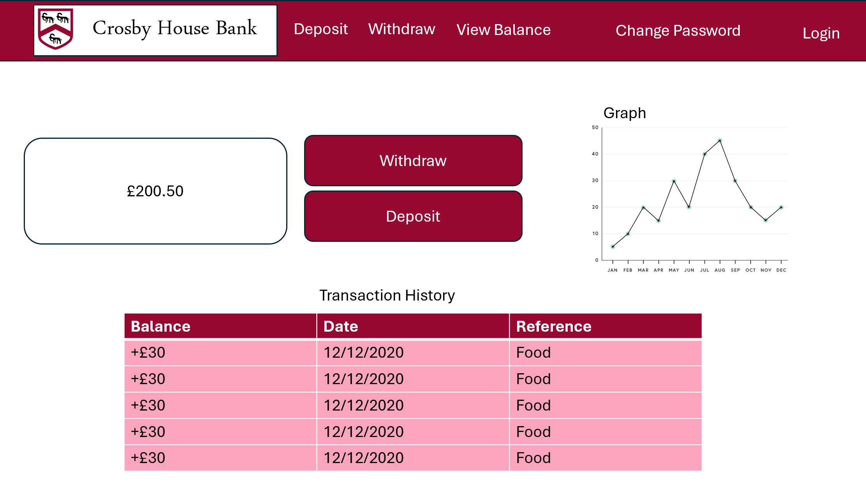

**Usability features:**

* Buttons/Inputs will be labelled clearly with their purpose
* colours will match the theme of Crosby house.
* Nav Bar at the top of the page to allow students to navigate easier
* Font is easy to read
* Page is laid out in a neat manner
* Allows Users to change Password

**Tables:**

* TblUsers
* TblTransactions
* TblBalanceTrack

**Variables:**

* Session: Username
* Session: UserID
* Password
* Withdrawn Money
* Session: HouseBank

**Validation:**

As per table designs

**Algorithms:**

To find the students balance:

SELECT Balance FROM TblUsers WHERE :username LIKE Username

Updating the students balance:

:balance=balance-withdraw

UPDATE `TblUsers` SET `Balance`='[Balance]' WHERE :userID like UserID

Adding Transaction to table:

"INSERT INTO TblTransactions (UserID,TransactionID,Amount,Date,Type ,Confirmed,Description)VALUES(;userID,null,:amount,:date,’1’,null,:description)"

Adding the New Balance to balance track:

"INSERT INTO TblBalanceTrack (UserID,Balance,Date,Year)VALUES (:userID,:balance,:date,,:year)"

HouseBank= HouseBank – withdrawn money

To change Password:

Password=str(input(“Enter New Password”)

UPDATE TblUsers SET Password = [Password] WHERE :userID like UserID

**Justification:**

The first statement will display the students balance on the page.

The second algorithm will take the value of the withdrawal and subtract it from the students balance. It will then update the students balance in the TblUsers table

The third algorithm will add the transaction to TblTransactions.

The fourth algorithm will add the student’s new balance to the table so that it can be referred to at a later date.

The last algorithm will allow the users to change the password

**Test:**

User test data

Transaction Test Data

Balance Track Test Data

### Student Deposit Page

**Page Overview**

This is the page students will see when they want to deposit money. In the actual project this will be split into two pages but the second page will be a blank processing page so I combined the two.

**Page Design**

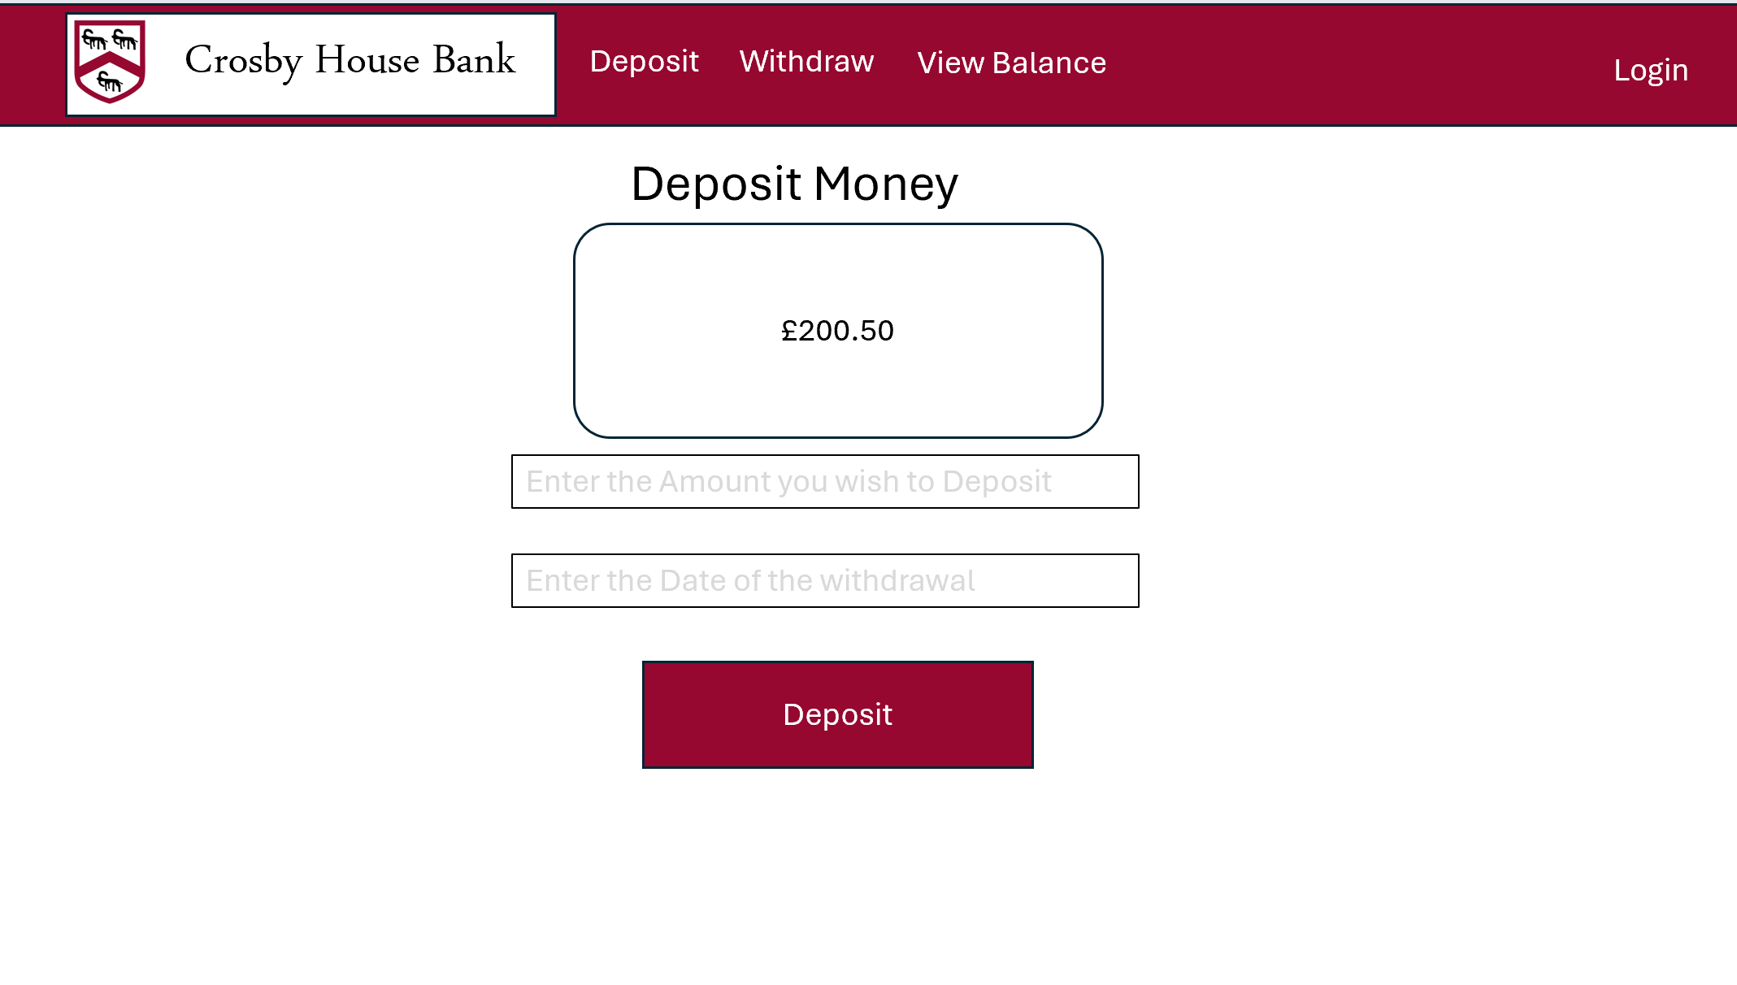

**Usability features:**

* Buttons will be labelled clearly with their purpose
* colours will match the theme of Crosby house.
* Nav Bar at the top of the page to allow students to navigate easier
* Font is easy to read
* Page is laid out in a neat manner

**Tables:**

* TblUsers
* TblTransactions
* TblBalanceTrack

**Variables:**

* Session: Username
* Session: UserID
* Deposited Money
* Session: HouseBank

**Validation:**

As per table designs

**Algorithms:**

To find the students balance:

SELECT Balance FROM TblUsers WHERE :username LIKE Username

Updating the students balance:

:balance=balance+deposit

UPDATE `TblUsers` SET `Balance`='[:balance]' WHERE :userID like UserID

Adding Transaction to table:

"INSERT INTO TblTransactions (UserID,TransactionID,Amount,Date,Type ,Confirmed, Description)VALUES (:userID,null,:amount,:date,’0’,null,null)"

Adding the New Balance to balance track:

"INSERT INTO TblBalanceTrack (UserID,Balance,Date,Year)VALUES (:userID,:balance,:date,,:year)"

HouseBank= HouseBank + deposit

**Justification:**

The first statement will display the students balance on the page.

The second algorithm will take the value of the deposit and add it to the students balance. It will then update the students balance in the TblUsers table

The third algorithm will add the transaction to TblTransactions.

The fourth algorithm will add the student’s new balance to the table so that it can be referred to at a later date.

This will then update the house bank session variable

**Test:**

User test data

Transaction Test Data

Balance Track Test Data

### Admin Home Page

**Page Overview**

This is the page the administrator will be guided to when logging in.

**Page Design**

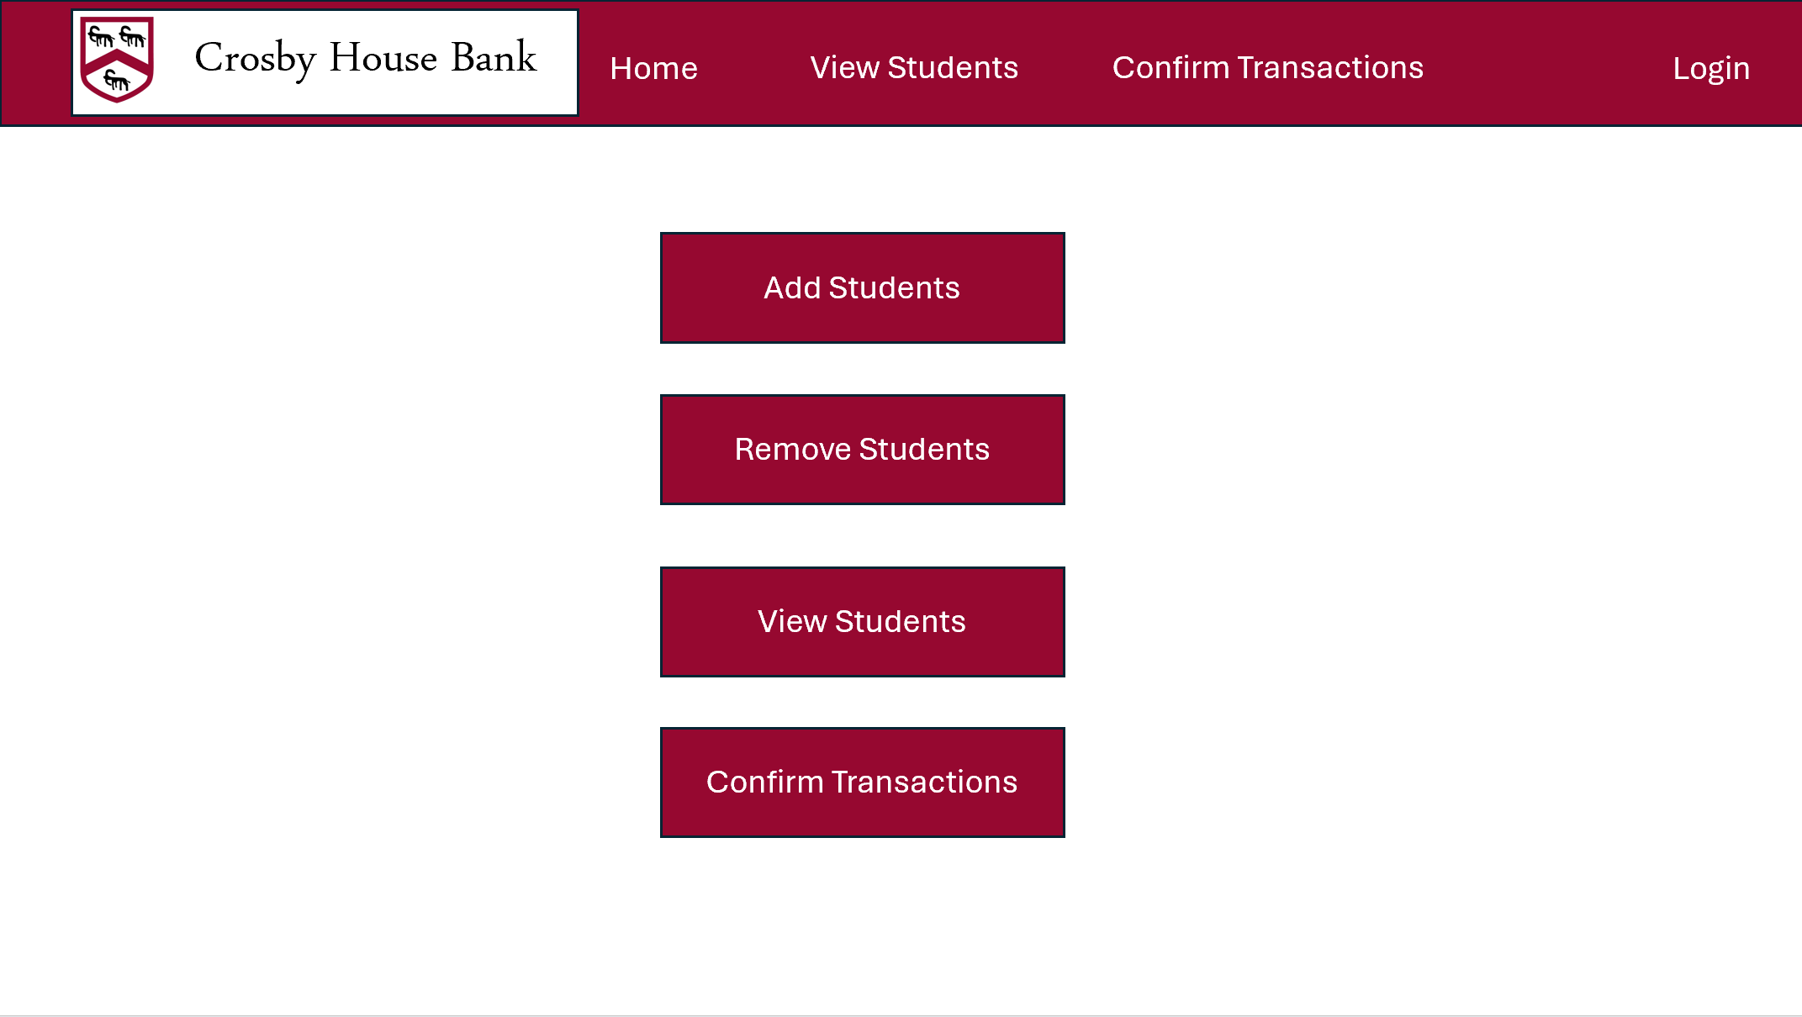

**Usability features:**

* Buttons will be labelled clearly with their purpose
* colours will match the theme of Crosby house.
* Nav Bar at the top of the page to allow the admin to navigate easier
* Font is easy to read
* Page is laid out in a neat manner

**Tables:**

* No tables

**Variables:**

* Session: Username
* Session: UserID

**Validation:**

As per table designs

**Algorithms:**

No algorithms

**Test:**

No Test Data

### Admin add students page

**Page Overview**

This is the page that the admin will use to add users to the database.

**Page Design**

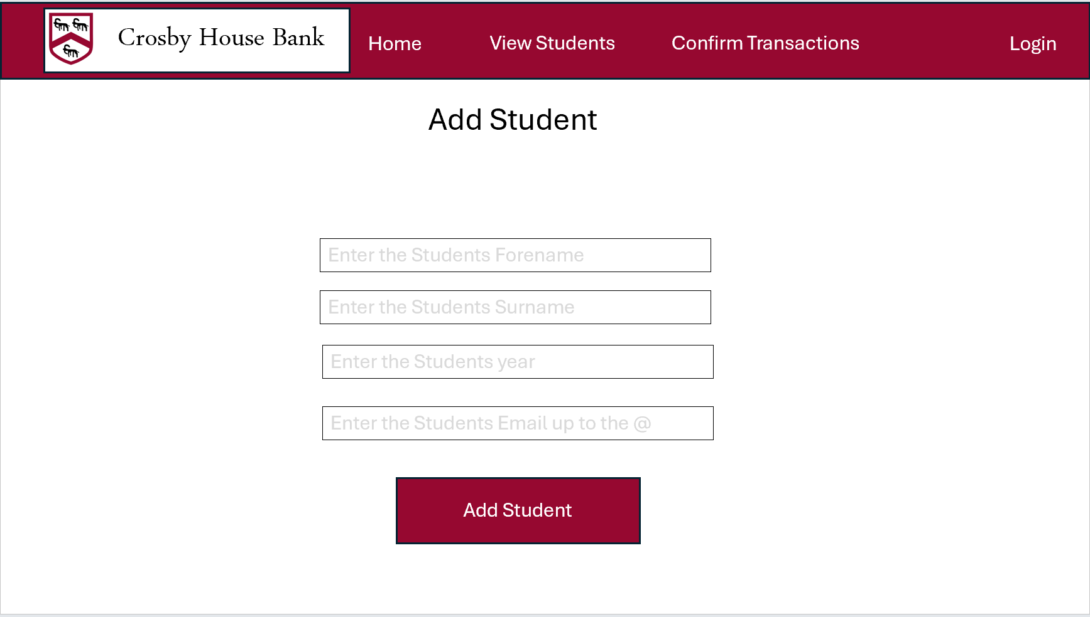

**Usability features:**

* Buttons will be labelled clearly with their purpose
* colours will match the theme of Crosby house.
* Nav Bar at the top of the page to allow students to navigate easier
* Font is easy to read
* Page is laid out in a neat manner
* All inputs are clearly labelled with their purpose

**Tables:**

* TblUsers

**Variables:**

* Session: Username
* Session: UserID
* Username, Surname, Year, Forename

**Validation:**

As per table designs

**Algorithms:**

INSERT INTO `TblUsers`(`UserID`, `Forename`, `Surname`,Password`,`Balance`,`Year`,`Role`) VALUES(null,:forename,:surname,null,null,:year,null)

**Justification:**

This will insert the new user into the database

**Test:**

User test data

### Admin Remove Students Page

**Page Overview**

This is the page that the admin will use to remove students from the database

**Page Design**

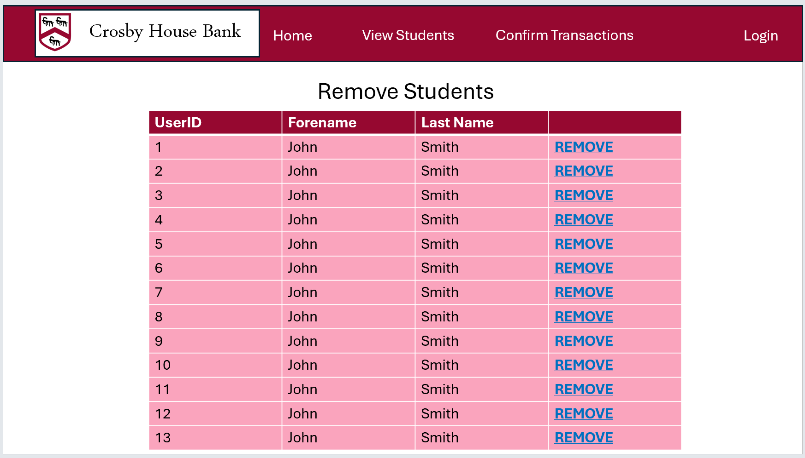

**Usability features:**

* Buttons will be labelled clearly with their purpose
* colours will match the theme of Crosby house.
* Nav Bar at the top of the page to allow students to navigate easier
* Font is easy to read
* Page is laid out in a neat manner
* All inputs are clearly labelled with their purpose

**Tables:**

* TblUsers

**Variables:**

* UserID

**Validation:**

As per table designs

**Algorithms:**

SELECT Forename, Surname FROM TblUsers WHERE role LIKE 0

DELETE FROM TblUsers WHERE :userID LIKE UserID

**Justification:**

The first SQL statement will display all of the users that are listed as students in the database

This will remove the selected user from the database.

**Test:**

User test data

### Admin View Students Page

**Page Overview**

This page will contain a list of all of the students in Crosby house. The admin will be able to select one of the student which will direct them to the individual student view page that is shown above. The admin can also select the student spending button

**Page Design**

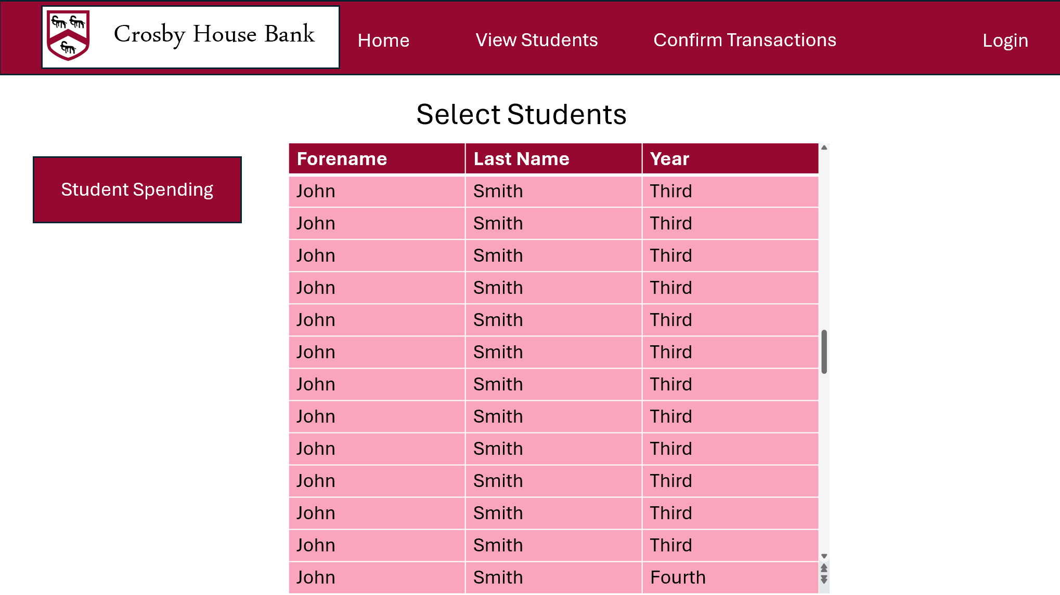

**Usability features:**

* Buttons will be labelled clearly with their purpose
* colours will match the theme of Crosby house.
* Nav Bar at the top of the page to allow the admin to navigate easier
* Font is easy to read
* Page is laid out in a neat manner
* All inputs are clearly labelled with their purpose
* Buttons will be highlighted when the cursor is hovering over to clearly show the selection

**Tables:**

* TblUsers

**Variables:**

* Session: UserID
* Username,Surname,Year

**Validation:**

As per table designs

**Algorithms:**

Select Forename,Surname,Year FROM TblUsers WHERE role LIKE 0

**Justification:**

This will display all of the users in the database

**Test:**

User test data

### Admin Student Spending Page

**Page Overview**

This page will display all of the students spending in a graph format. This will allow the admin to view trends in spending across year groups. The admin will be able to select and deselect which year groups will be displayed on the graph.

**Page Design**

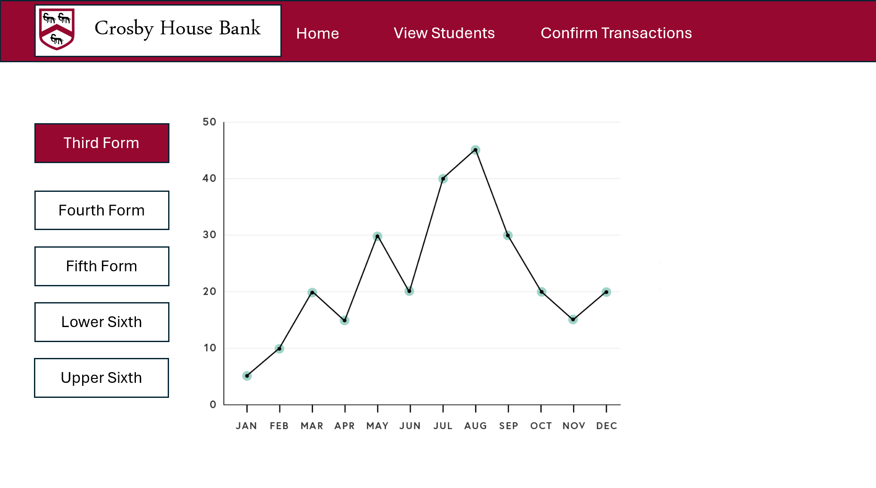

**Usability features:**

* Buttons will be labelled clearly with their purpose
* colours will match the theme of Crosby house.
* Nav Bar at the top of the page to allow the admin to navigate easier
* Font is easy to read
* Page is laid out in a neat manner
* All inputs are clearly labelled with their purpose
* Buttons will be highlighted when the cursor is hovering over to clearly show the selection
* Buttons will change colour to show which year groups have been selected

**Tables:**

* TblUsers
* TblBalanceTrack

**Variables:**

* UserID
* Third Form
* Fourth Form
* Fifth Form
* Lower Sixth
* Upper Sixth
* All

**Validation:**

As per table designs

**Algorithms:**

If All == true:

Select Balance, Date FROM TblBalanceTrack

Else:

If Third Form == True:

Select Balance, Date FROM TblBalanceTrack WHERE year LIKE third

If Fourth Form == True:

Select Balance, Date FROM TblBalanceTrack WHERE year LIKE fourth

If Fifth Form == True:

Select Balance, Date FROM TblBalanceTrack WHERE year LIKE fifth

If Lower Sixth == True:

Select Balance, Date FROM TblBalanceTrack WHERE year LIKE lower sixth

If Upper Sixth == True:

Select Balance, Date FROM TblBalanceTrack WHERE year LIKE upper sixth

**Justification:**

The first if statement will check whether all of the year groups have been selected. If they have then it will display all of the users on the line graph. If not then each year group will be checked as to whether they have been selected. If the year group has been selected then they will be displayed on the line graph.

**Test:**

User test data

Balance Track Test Data

### Admin Confirm Transactions Page

**Page Overview**

This page will allow the admin to confirm as to whether the student has received the money from house bank or whether the student has put money into house bank.

**Page Design**

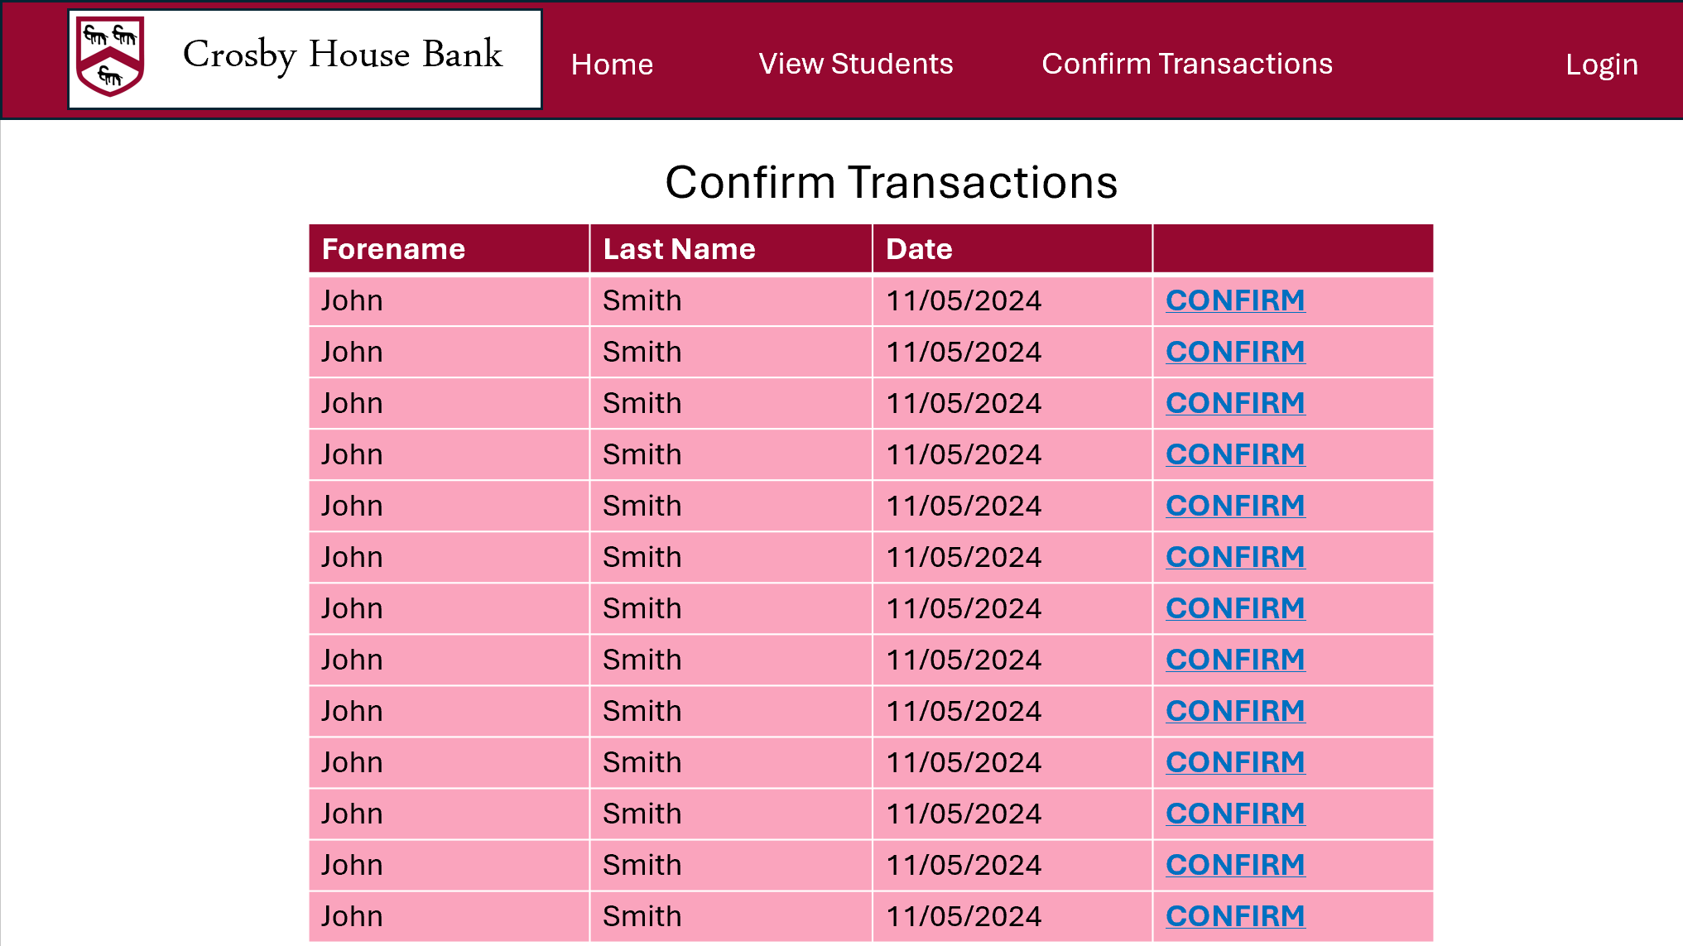

**Usability features:**

* Buttons will be labelled clearly with their purpose
* colours will match the theme of Crosby house.
* Nav Bar at the top of the page to allow the admin to navigate easier
* Font is easy to read
* Page is laid out in a neat manner
* All inputs are clearly labelled with their purpose

**Tables:**

* TblUsers
* TblTransactions

**Variables:**

* Session: UserID
* userID

**Validation:**

As per table designs

**Algorithms:**

Select UserID, Date FROM TblTransactions WHERE confirmed LIKE FALSE

SELECT Forename, Surname FROM TblUsers WHERE UserID LIKE userID

**Justification:**

The first SQL statement will select all of the transactions that have not been confirmed by selecting the date and the userID. The userID will then be used to select the matching Forename and Surname to the userID. This will then all be displayed on one line in php.

**Test:**

User test data

Transaction test data

### Admin Balance Update Page

**Page Overview**

This page will allow the admin to confirm as to whether the student has received the money from house bank or whether the student has put money into house bank.

**Page Design**

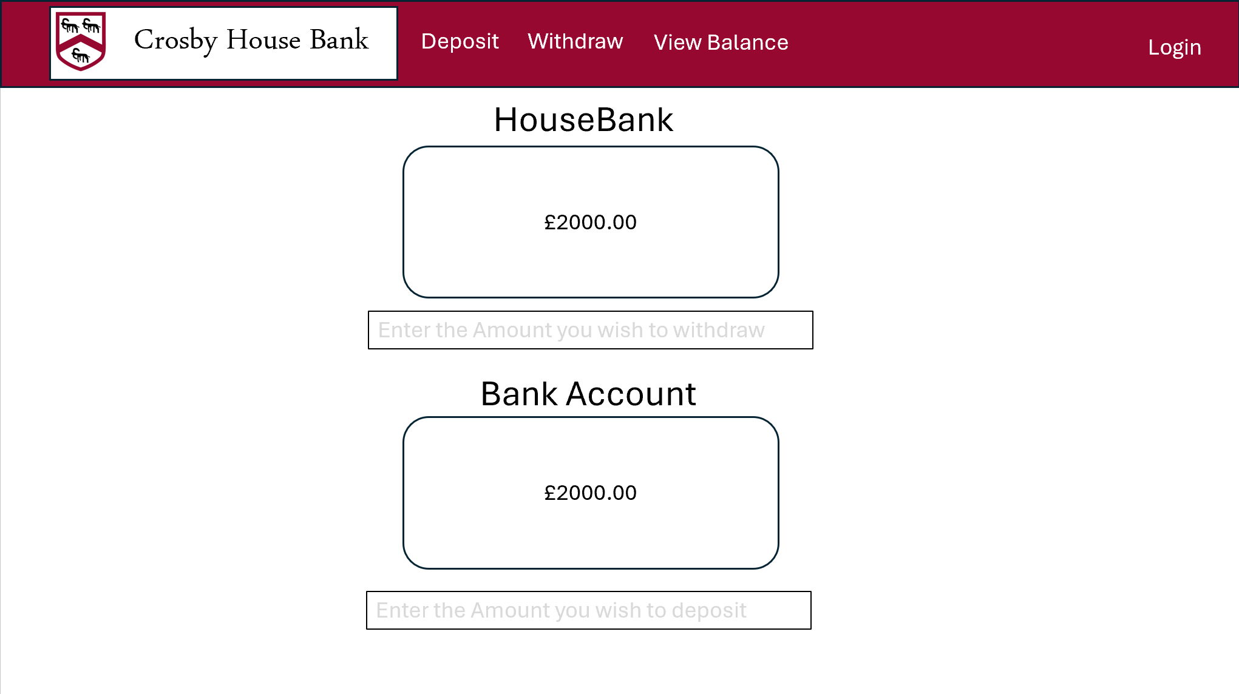

**Usability features:**

* Buttons will be labelled clearly with their purpose
* colours will match the theme of Crosby house.
* Nav Bar at the top of the page to allow the admin to navigate easier
* Font is easy to read
* Page is laid out in a neat manner
* All inputs are clearly labelled with their purpose

**Tables:**

* No tables

**Variables:**

* Session: UserID
* Session: HouseBank
* Session: BankAccount
* Withdraw

**Validation:**

As per table designs

**Algorithms:**

Print(HouseBank)

Print(BankAccount)

Withdraw=input(“Amount Withdrawn from Bank account”)

HouseBank= HouseBank+Withdraw

Deposit=input(“Amount deposited into bank account”)

Bankaccount = Bankaccount+deposit

**Justification:**

The amount of money in both housebank and the bank account will be displayed on the page. The admin will then be able to manually update how much money has been withdrawn from the bank account to house bank or the amount of money in the house bank account.

**Test:**

no test data

# Development

## Creating Database and Tables

### Creating Connection Page

I will need to create

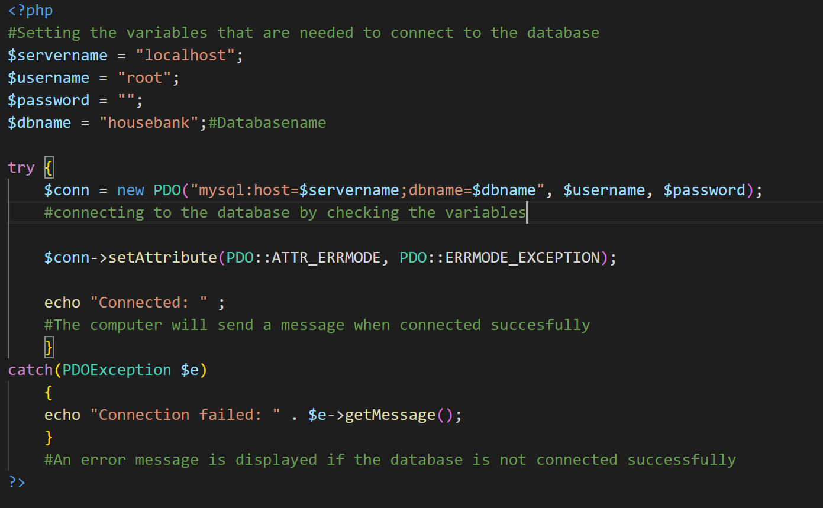

**Testing:**

By going to the URL localhost/Computing-Coursework and clicking on connection.php

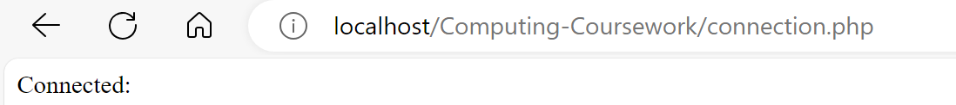

It is working properly

### Creating Database and TblUsers

I will be using an install page to create the database on launch.



### 

Using my table design in the design section I created the table for users. I ensured that all variables were validated with a presence check by making all of the variables not null. I have also validated the password to default to “password” and the role to default to 0 to make the default user a student

**Install Page:**

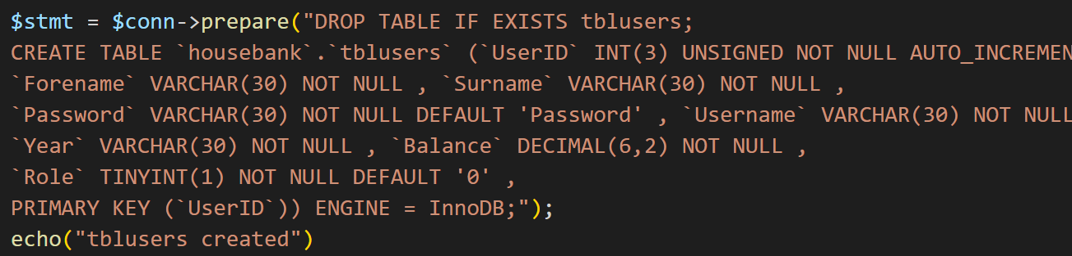

This will add TblUsers to the database if it is not present on launch

**Adding an admin**:

I then added the admin to the database using the test data that was implemented in the design section



**Testing:**

I will be testing both creating the database and tblusers at the same time to test whether the install page can create a table and a database

**Error1:**



When testing the install.php for the first time I realised I needed to have the database already created in order to connect to the database.

In order to fix this I added a connection part to the install page so that the page can connect to local host if the database has not been created.

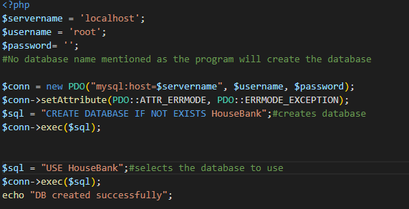

**Error2:**



After implementing this new code to I got an error message with putting the table into the database. I found that the problem was that I did not have any code that was running the code that inputted the table into the database. So in order to fix this I just added the lines of code below.

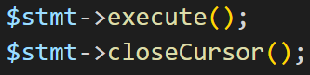

**Success:**

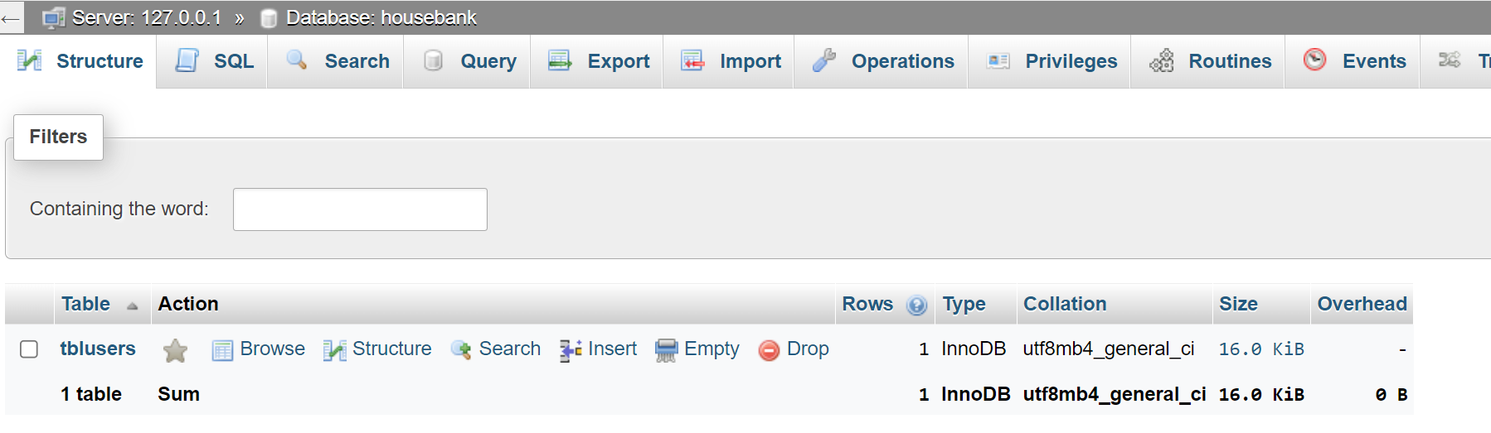



After fixing my code I have successfully created the database and the user table as well as adding the admin to the database.

### Creating TblTransactions

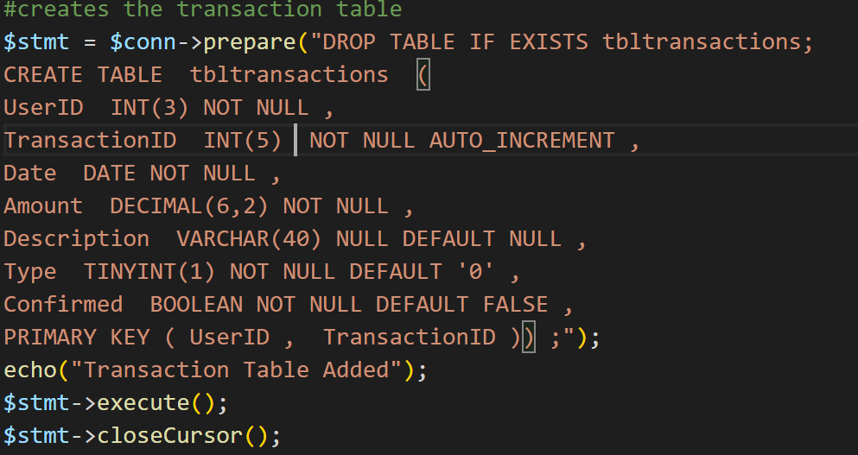

Using the table design in the design section I have created tbltransactions. I have included the presence check for all of the variables except for the description as mentioned in the validation part of the table design.

**Testing:**



The problem that I had was that in the version of my sql you cannot have a two variable primary key and have one variable be auto incremented. To fix this I made changed the primary keys to only the transaction id. This fixed the problem and created the database.

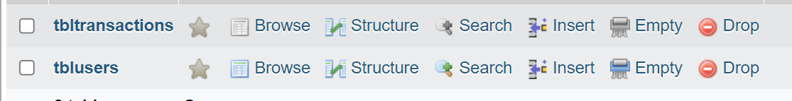

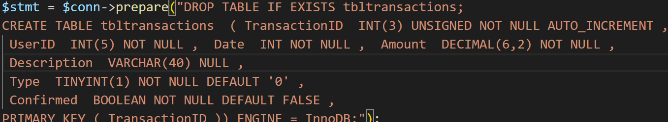

### Creating TblBalanceTrack

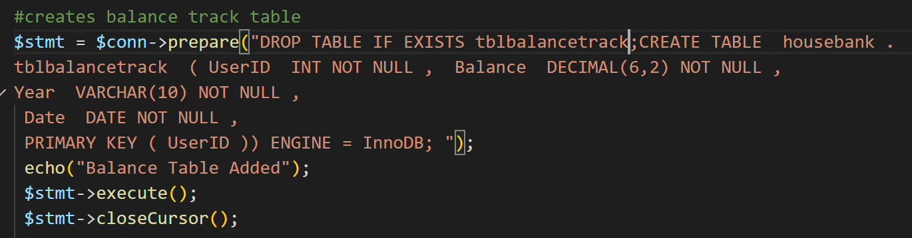

Using the table design in the design section I made the balance track table.

**Testing:**

It was added to the database



## Creating Admin Pages

### Admin Home Page

When coding the home page I followed the design in the design section closely ensuring all of the usability features. I did not test the page as the functionality of the page is not very complicated as there is no SQL or php.

**Code:**

<!DOCTYPE html>

<html>

<head>

  <!-- Imports Style Sheets from bootstraps as well as linking to the local stylesheet-->

  <meta charset="utf-8">

  <meta name="viewport" content="width=device-width, initial-scale=1">

  <link rel="stylesheet" href="https://maxcdn.bootstrapcdn.com/bootstrap/3.4.1/css/bootstrap.min.css">

  <link rel="stylesheet" href="styles.css">

  <script src="https://ajax.googleapis.com/ajax/libs/jquery/3.6.4/jquery.min.js"></script>

  <script src="https://maxcdn.bootstrapcdn.com/bootstrap/3.4.1/js/bootstrap.min.js"></script>

</head>

<body>

<!-- Admin Nav bar with links to all of the subpages for the admin-->

<nav class="navbar navbar-inverse redback  " >

<div class="container-fluid " >

    <div class="navbar-header "  >

    <img class="banner" src="CrosbyBanner.png" alt="OundleChoralSociety">

    </div>

    <ul class="nav navbar-nav right ">

    <li> <a  href="#about"><p class="white bannertext">Home</p> </a></li>

    <li><a  href="#concerts&events"><p class="white bannertext">View Students</p></a></li>

    <li><a  href="#members"><p class="white bannertext">Confirm Transactions</p></a></li>

    <li><a  href="#contactus"><p class="white bannertext loginalign">Login</p></a></li>

    </ul>

</div>

</nav>

</body>

<!-- Buttons for admin-->

<!-- Link to  add students page-->

  <div class="container-fluid centre">

      <a href="students.php" ><img class="addbutton padding " src="Addstudents.png" alt="addstudents"></a>

    </div>

  <!-- Link to  remove students page-->

    <div class="container-fluid centre">

      <a href="removestudents.php" ><img class="addbutton padding" src="Removestudents.png" alt="removestudents"></a>

    </div>

  <!-- Link to  view students page-->

    <div class="container-fluid centre">

      <a href="viewstudents.php" ><img class="addbutton padding" src="Viewstudents.png" alt="Viewstudents"></a>

    </div>

    <!-- Link to transactions page-->

    <div class="container-fluid centre">

      <a href="confirmtransactions.php" ><img class="addbutton padding" src="Confirmtrans.png" alt="Confirm Transactions"></a>

    </div>

</html>

**Page:**

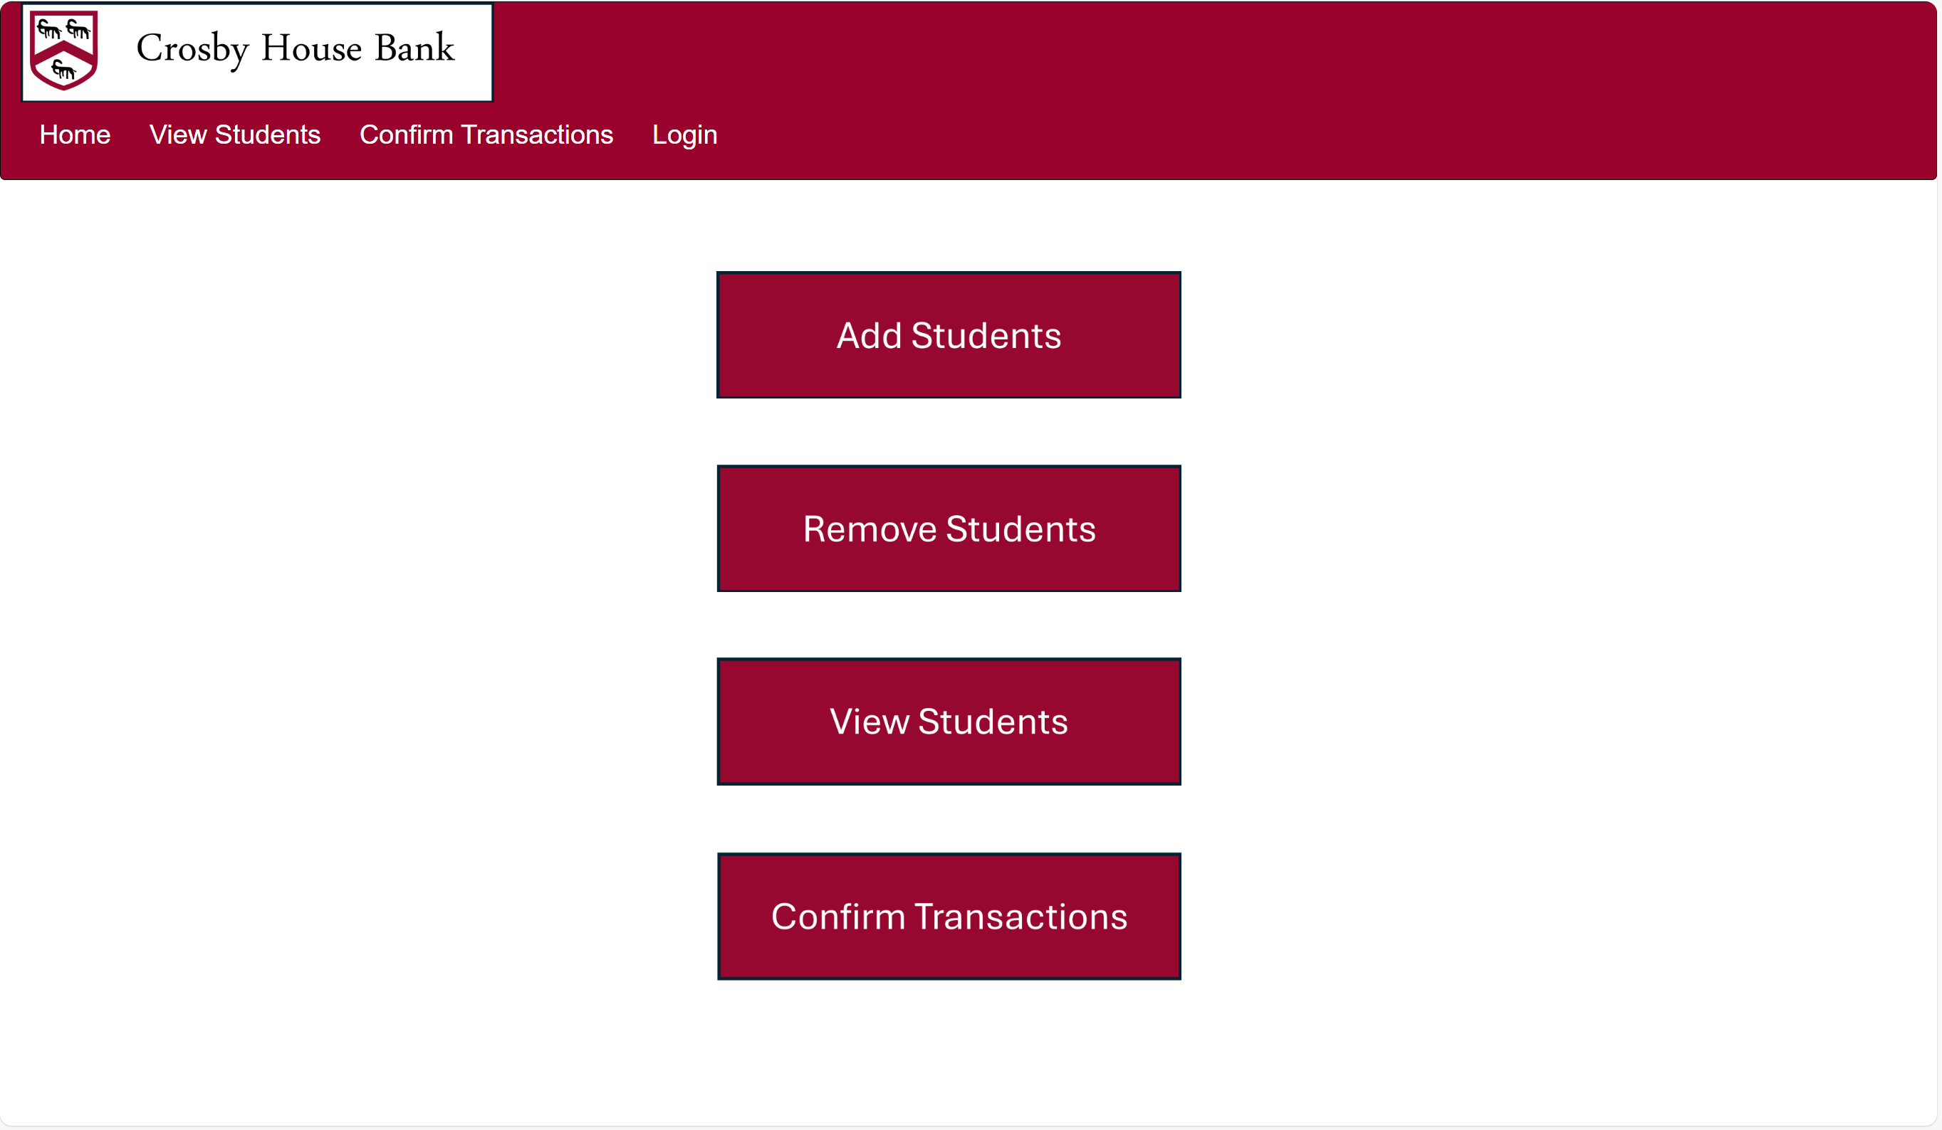

I will fix some of the formatting problems in the nav bar so that they match that of the design section at a later date but for now the page works as it should.

### Add Users Pages

This will be divided into two pages students.php and Addstudents.php.

The Users Page will allow the admin to input the users detail into the database.

Below is how the page will look.

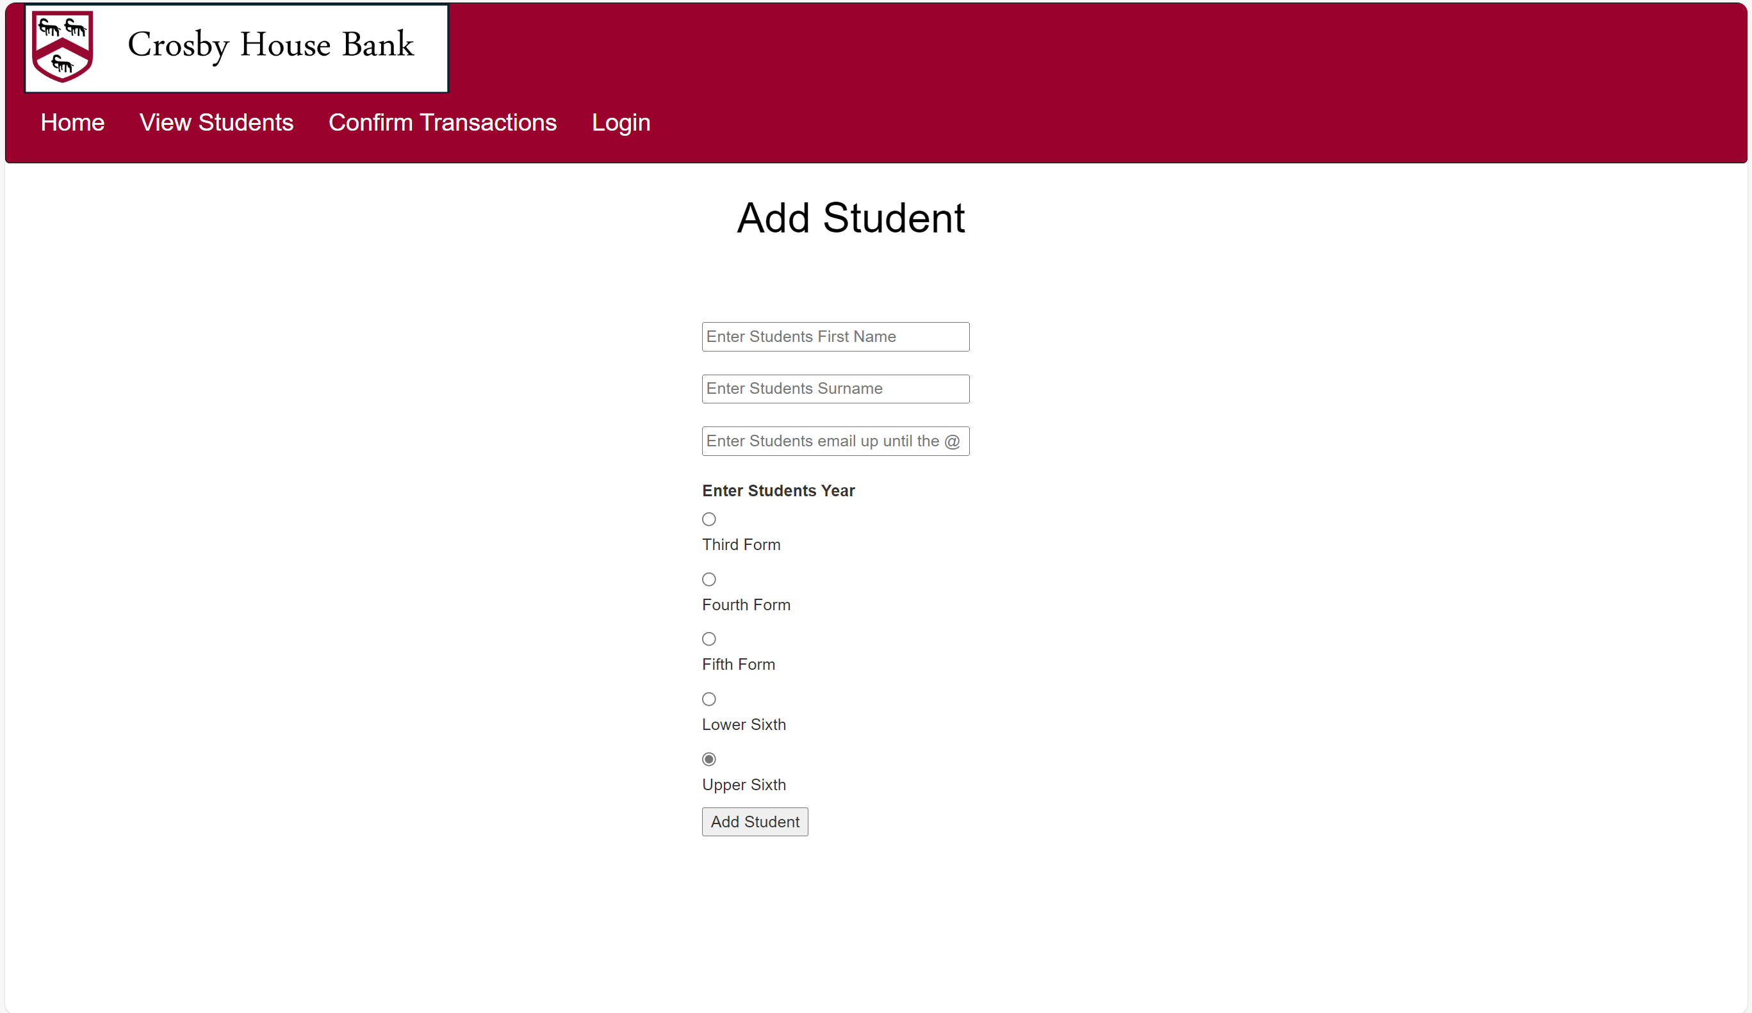

**Code:**

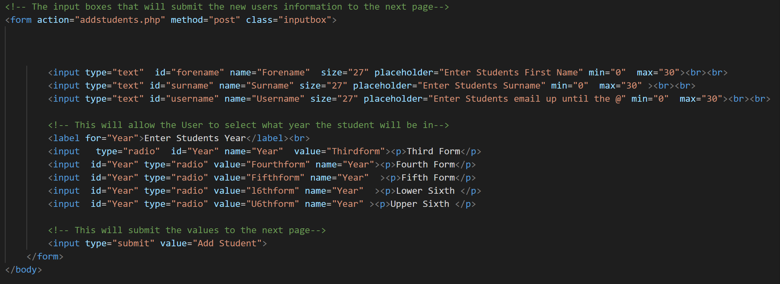

In this code I have included input validation. For example I have included range check to ensure that the user does not exceed the maximum characters of 30 for the forename, surname and username. I have also made the year input a radio input so that the user can only select valid inputs. I have not managed to do a format check for the username.

**Code for Addstudents.php:**

<?php

    array_map("htmlspecialchars", $_POST);

    include_once("connection.php");

    #this will choose what year will be inputted into the database depending on what the user selected on the last page.

    switch($_POST["Year"]){

        case "Thirdform":

            $year="Third";

            break;

        #This would make the user be in Third Form in the table

        case "Fourthform":

            $year="Fourth";

            break;

        case "Fifthform":

            $year="Fifth";

            break;

        case "L6thform":

            $year="Lower Sixth";

            break;

        case "U6thform":

            $year="Upper Sixth";

            break;

    }

    #This uses Sql to insert the inputted variables in the TblUsers

    $stmt = $conn->prepare("INSERT INTO TblUsers (UserID,Forename,Surname,Password,Username,Balance,Year,Role)VALUES (null,:forename,:surname,null,:username,null,:year,null)");

    #This sets the code post variables as variables that can be inserted into the table

    $stmt->bindParam(':forename', $_POST["Forename"]);

    $stmt->bindParam(':surname', $_POST["Surname"]);

    $stmt->bindParam(':username', $_POST["Username"]);

    $stmt->bindParam(':year', $year);

    $stmt->execute();

$conn=null;

?>

</body>

<html>

<!-- This will create hyperlinks that the admin can use to return to the home page-->

<a href="students.php"><img class="addbutton padding" src="Newuser.png" alt="add new user"></a><br>

<a href="Adminhome.php"><img src="image.png" alt="return home"></a>

</html>

The switch case iteration will set the variable $year to whatever year the student is in. This will validate the year input that the user has. In the SQL part I have made the password, role, and balance all null inputs so that they can be set to their default state.

**Testing:**

Using the test data in the design section I will be testing to see if the user input works.

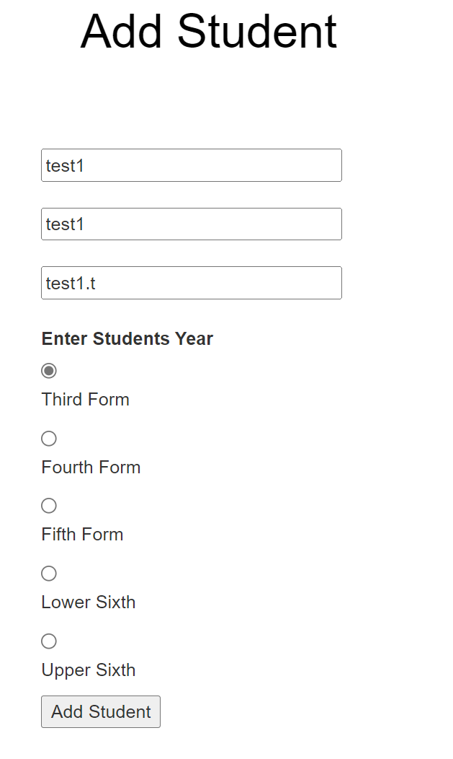

**Error1:**



The first error I got when testing was that the password input could not be null.

To fix this I changed the password on the input page to “Password”





This also gave me an error message.

To fix this I changed all of the null inputs to default



This ended up fixing the problem. I then added the rest of the test users.

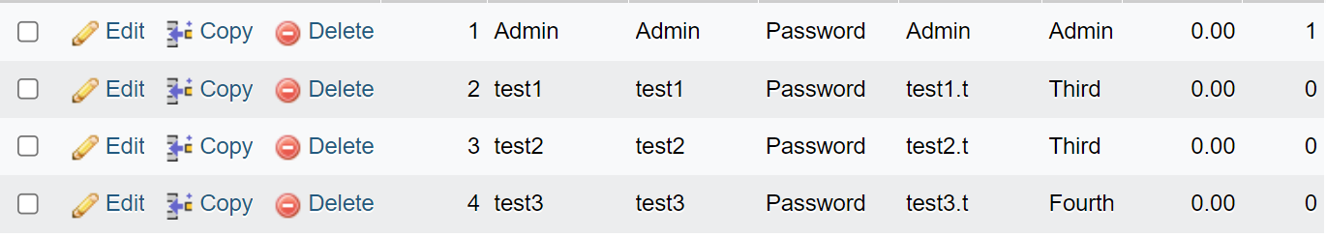

### Remove Users Page

### Remove Users Pages